Advanced Exam Study Guide

Advanced Preparation

**Tools**:

* Multi-Field Formula 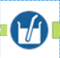
  + Use this tool when a need arises to apply a common formula across multiple columns (e.g., applying an UPPERCASE function to all TEXT fields – *Uppercase([_CurrentField_])*
* Multi-Row Formula 
  + Create Multi-Row Formula expressions using Row variables
  + Determine how to correctly configure the Multi-Row Formula tool for “values for rows that don’t exist”
  + Be aware that you can use this tool to update an existing field or create a new field. For example, it may be easier to update an existing field to fill in missing values instead of creating a new field and referencing both the existing field and the new field (see the screenshot below).

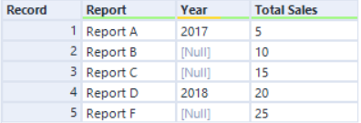

* Random % Sample 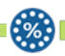
  + Identify how the Random % Sample tool selects and processes records to output

**General tasks**:

* Correctly format string expressions to produce a given output
* Identify the specifiers and separators that transform a given date
* Identify the results of a compound condition in the Filter tool (condition joined by and/or operators)
* Identify the output of complex expressions

Advanced Join & Parse

**Tools**:

* Join Multiple 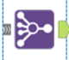
  + Determine the number of records that result from a multidimensional join
  + Identify how the Join Multiple tool processes records that don’t match
* RegEx 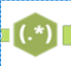
  + Identify the regular expression that would transform a given input to a given output
  + Differentiate Match and Parse output methods of the RegEx tool
    - The Match method evaluates a given regex against each cell in a column. It outputs a *True* or *False* (the screenshot below had a regular expression of “\d+” with the *Case Insensitive* box unchecked and the *Error if Not Matched* box unchecked).

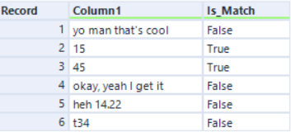

* + - The Parse method allows you to extract data from a cell by evaluating a regex. Marked groups (i.e., surrounding parts of the regex with parentheses) are required. Each marked group represents a new column that will be created.

Spatial Analytics

**Tools**:

* Buffer 
* Create Points 
* Distance 
* Find Nearest 
* Generalize 
* Poly-Build 
* Poly-Split 
* Spatial Info 
* Spatial Match 
* Spatial Process 
  + The Spatial Process tool requires 2 polygon spatial objects and requires that they are both contained in the same row of data. Additional prep work is often required to get the data into the correct format to be used with this tool.
* Trade Area 

**General tasks**:

* Identify which tools can generate the centroid of a polygon <- Create Points, Spatial Info (Centroid as SpatialObj), Summarize (Create Centroid), Formula (ST_Centroid)
* Interpret the results of interactions between Target and Universe objects
* [Differentiate the functionality of the T and U input anchors of the Find Nearest tool](https://help.alteryx.com/2018.2/FindNearest.htm?tocpath=Tools%7CTool%20Categories%7CSpatial%7C_____4)
* [Identify the spatial object that’s created from the intersection of two spatial objects](https://help.alteryx.com/20221/designer/spatial-process-results)
* [Identify the output of a Convex Hull build method](https://en.wikipedia.org/wiki/Convex_hull)
* [Determine how the Distance tool outputs the distance of a point within a polygon to the nearest edge of the polygon](https://help.alteryx.com/2018.2/Distance.htm?tocpath=Tools%7CTool%20Categories%7CSpatial%7C_____3)
* [Identify the tool that can decrease the number of nodes that make up a polyline or polygon](https://help.alteryx.com/2018.2/Generalize.htm)
* [Configure the Trade Area tool to create doughnuts](https://community.alteryx.com/t5/Alteryx-Designer-Knowledge-Base/Creating-Multi-Ring-Trade-Areas/ta-p/43416)
* Identify spatial functionality within the Summarize tool
* Identify spatial functionality within the Formula tool

Reporting

**Tools**:

* Interactive Chart 
  + Identify configuration options in the Interactive Chart tool
* Layout 
  + Determine how the Layout tool arranges snippets
* Overlay 
  + Identify the tool that can place reporting snippets on top of one another
* Render 
  + Identify the ways the Render tool can write out reporting snippets
* Report Map 
  + Identify the default outputs of the Report Map tool
* Report Text 
  + Determine ways the Report Text tool can accept incoming data
* Table 
  + Identify configuration options of the Table tool

**General tasks**:

* Identify the tools used to produce a given report
* Determine how to achieve batch reporting with the Reporting tools

Macros

**Tools**:

* Control Parameter 
* Macro Input 
* Macro Output 

**General tasks**:

* Determine which kind of macro (standard, iterative, batch) is the best solution for a given scenario
* Identify the number of outputs an iterative macro can produce
* Identify common reasons macros error
* Determine how to debug a macro interface
* Differentiate the functionality of macros versus apps
* Determine how to use an engine iteration number
* Configure a batch macro and an iterative macro

Analytic Applications

**Tools**:

* Action 
  + Determine when an Action tool is required between Interface and workflow tools
* Check Box 
* Drop Down 
  + Correctly format list values for the Drop Down tool
* Error Message 
* File Browse 
* Folder Browse 
* List Box 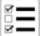
* Map 
  + Identify ways app users can interact with interface elements from the Map tool
* Numeric Up Down 
* Radio Button 
* Text Box 
* Tree 

**General tasks**:

* Configure chained applications
* Identify the Interface tools used to create a given App interface
* Identify which Interface tools can be used to input or output data in an App
* Identify common reasons why apps error

Data Investigation

**Tools**:

* Association Analysis 
* Field Summary 
* Frequency Table 
* Pearson Correlation 
  + Interpret the output of the Pearson Correlation tool and identify the variables that have the strongest correlation
* Scatterplot
  + Identify the configuration of the Scatterplot tool that produces a given graph
* Spearman Correlation 
  + Interpret the output of the Spearman Correlation tool

**General tasks**:

* Determine how to find p-values for correlations
* Differentiate the Spearman Correlation and Pearson Correlation tools
* Identify the tool that provides remarks and suggestions on data quality <- this is the ***Field******Summary*** tool.

Suggested Readings/Tips

* [Convex hull of a simple polygon](https://en.wikipedia.org/wiki/Convex_hull_of_a_simple_polygon)
* <https://regex101.com/>
* [Pearson correlation coefficient](https://en.wikipedia.org/wiki/Pearson_correlation_coefficient)
* [Tip] Have open on test day: <https://help.alteryx.com/20221/designer/datetime-functions>
* [Tip] Count weekday difference between two dates: <https://community.alteryx.com/t5/Alteryx-Designer-Discussions/Count-workday-difference-between-2-dates/td-p/92579>
* [Tip] How to generate totals and subtotals: <https://community.alteryx.com/t5/Engine-Works/How-to-Generate-and-Format-Totals-and-Subtotals/ba-p/916853>
* [Reporting] Understand how to display grouped data within an *Interactive Chart* tool. This example is from [Weekly Challenge 201](https://community.alteryx.com/t5/Weekly-Challenge/Challenge-201-Wage-Ain-t-Nothin-but-a-Number/td-p/522398).

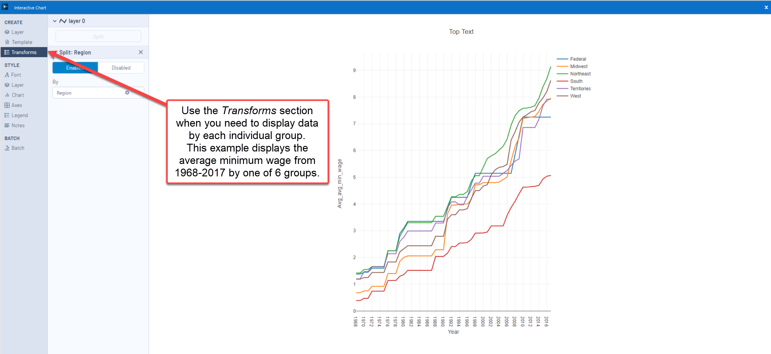

* [Reporting] Understand how to use thematic fields in the *Report Map* tool. This example is from [Weekly Challenge 218](https://community.alteryx.com/t5/Weekly-Challenge/Challenge-218-Car-Sales-Reporting/td-p/580155/highlight/false). Categorical fields (e.g., Vehicle Type) are displayed with a Tile Method of *Unique Value* and a Color Method of *Map*. Numerical fields (e.g., Sales) are displayed with one of the four Tile Methods shown in the second screenshot below and with a Color Method of *Ramp*.

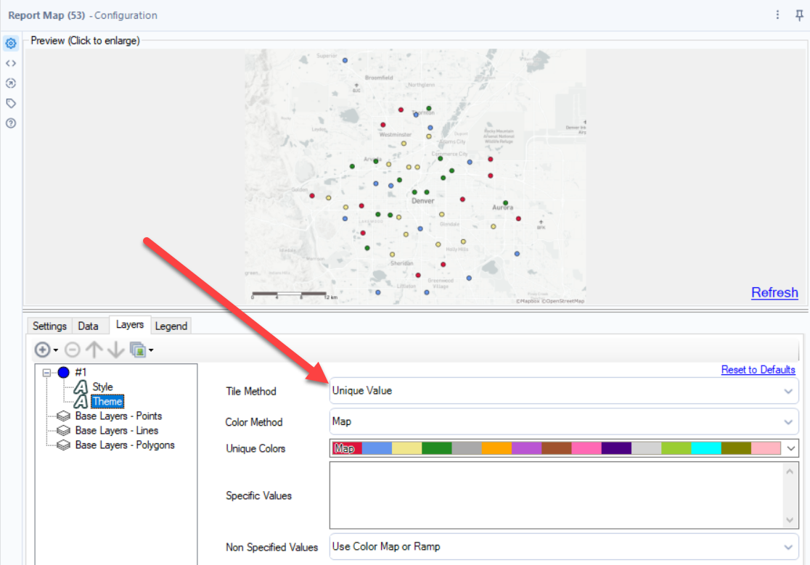

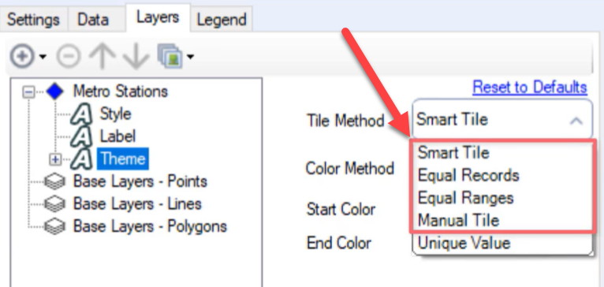

* [Reporting] When a row rule and column rule interfere with each other, the default is for the column rule to override the row rule. This can be swapped by selecting this box:

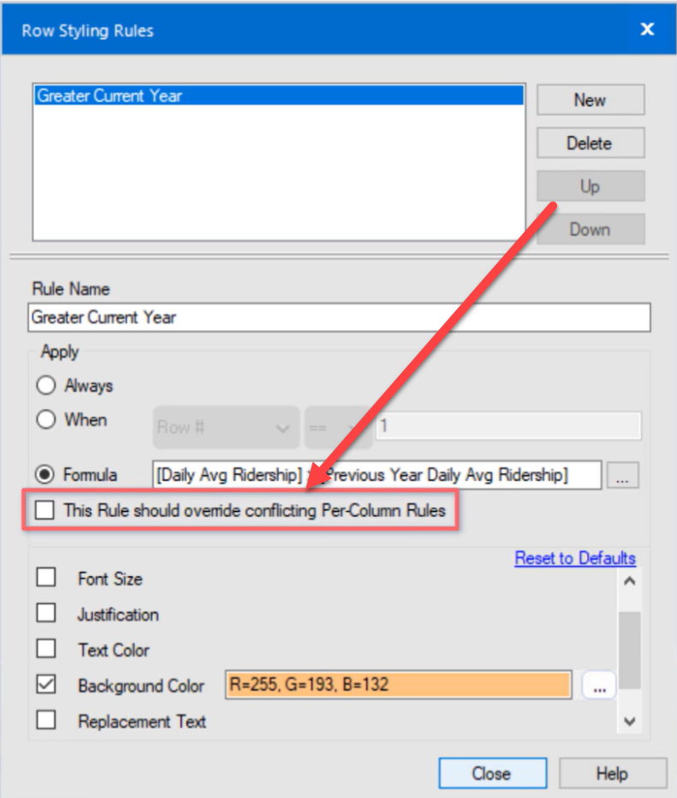

* [Reporting] If you want to compare prior year’s and current year’s data, for example, you will create two layers so the bar chart uses the same x axis, but each layer has its own data (as shown in the screenshot below).

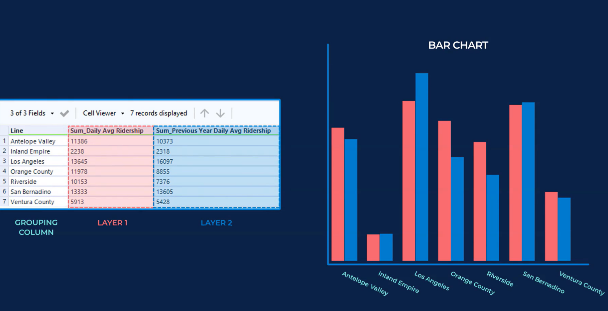

* [Reporting]

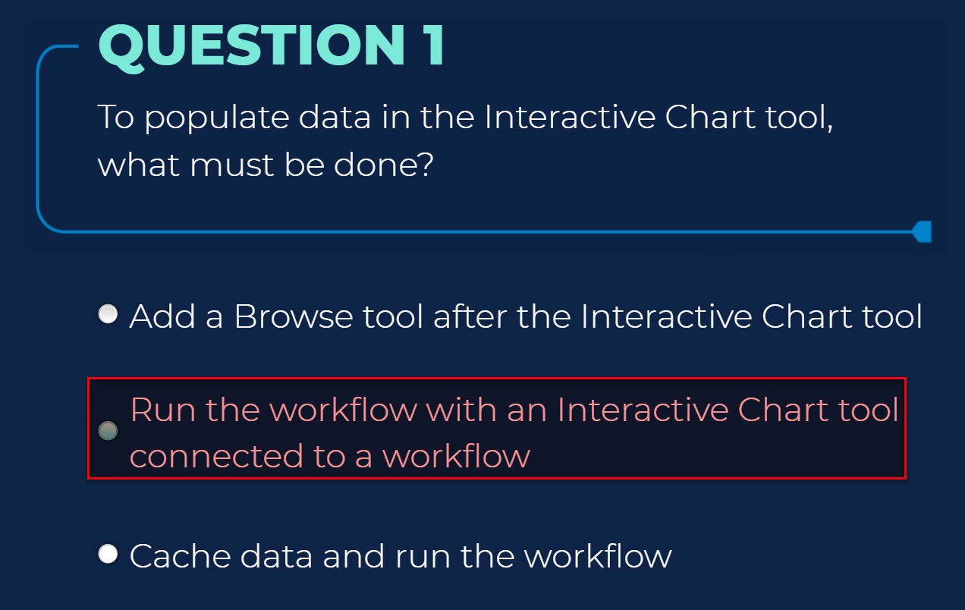

* [Reporting]

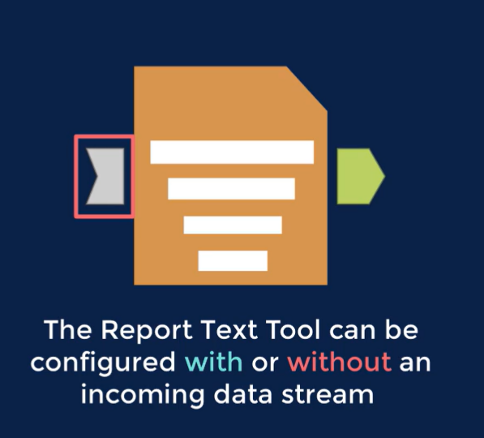

* [Reporting] Use case for displaying text above a field, like a header, by using a *Report Text* tool:

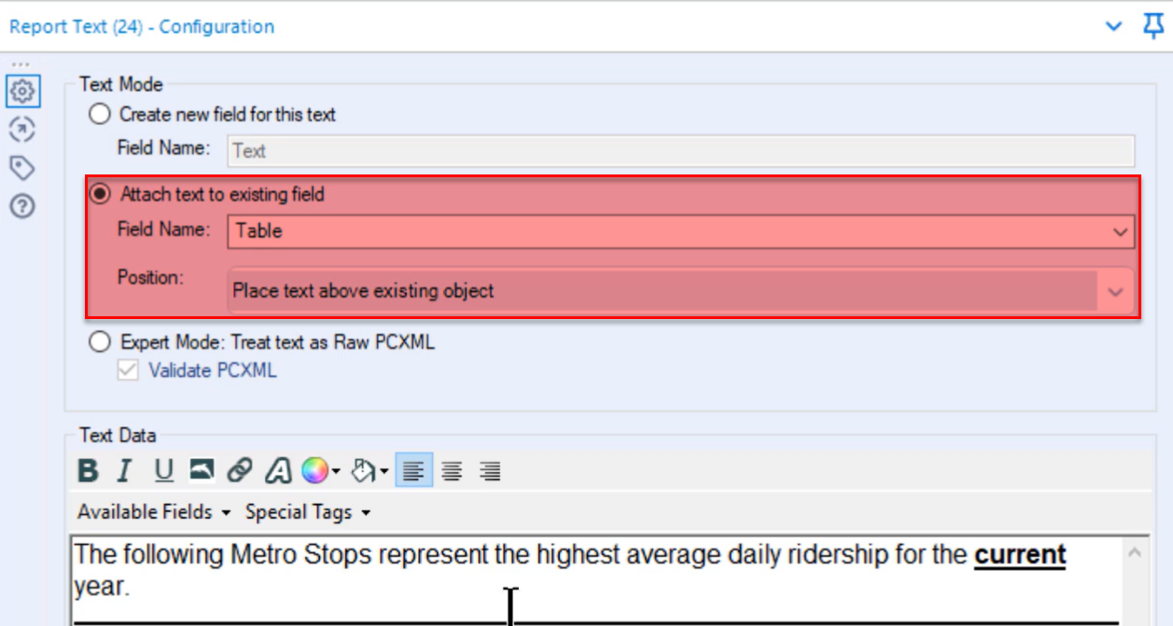

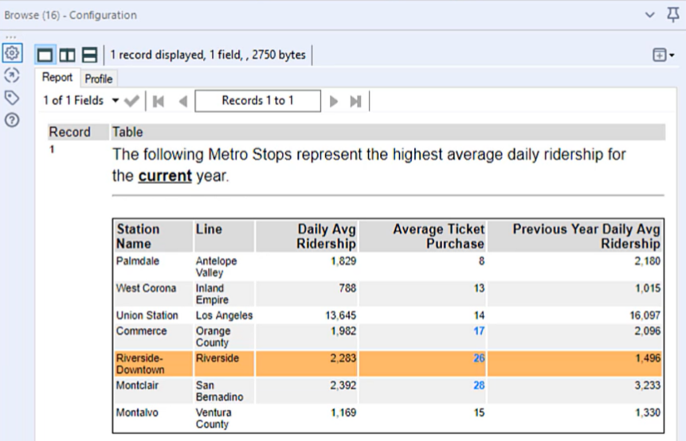

* [Reporting]

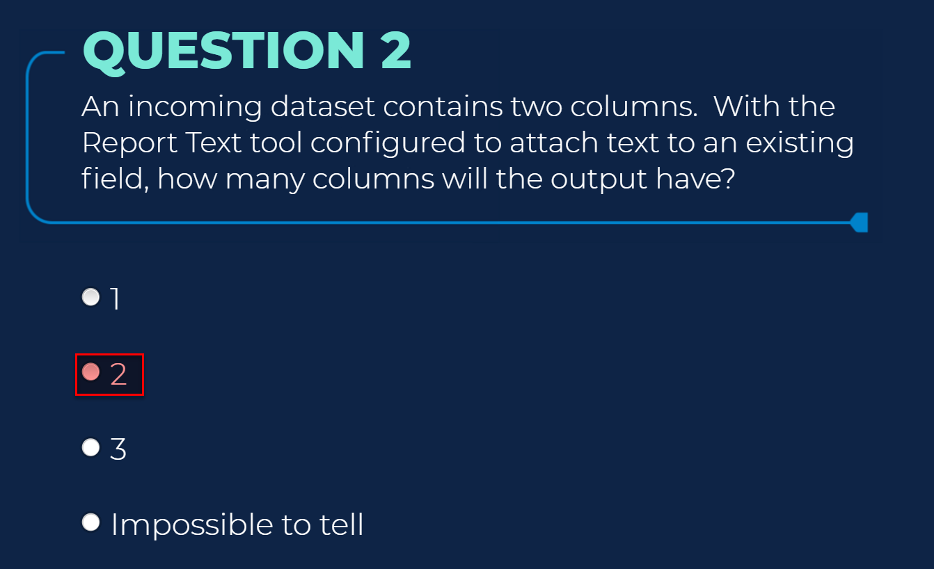

* [Reporting] When adding multiple reporting snippets together, for example, when creating a report, use the *Join Multiple* tool instead of the *Union* tool. The difference is that the *Join Multiple* tool will output all the different tools in a single row, whereas the *Union* tool will output several rows because of the different types of reporting snippets.

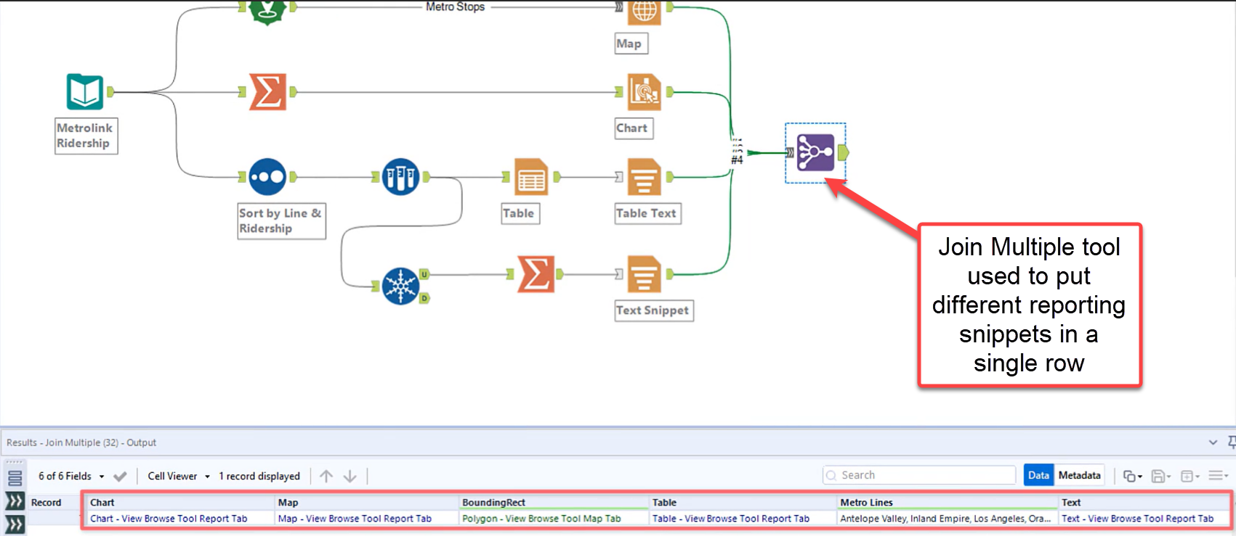

* [Reporting]

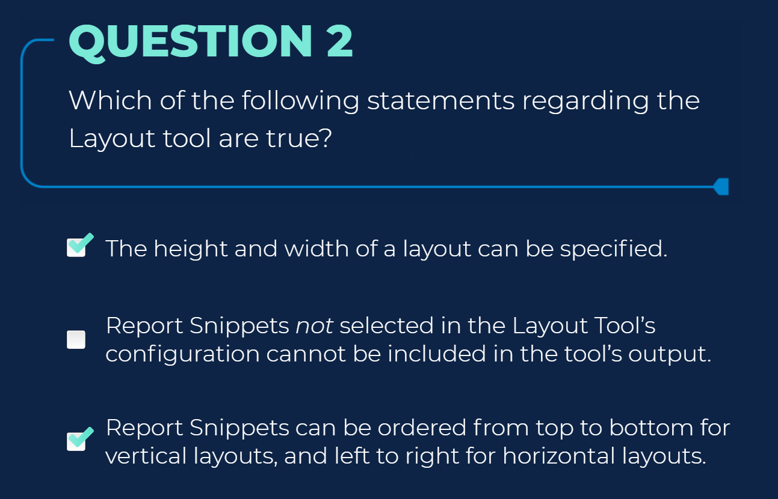

* [Reporting]



* [Reporting]

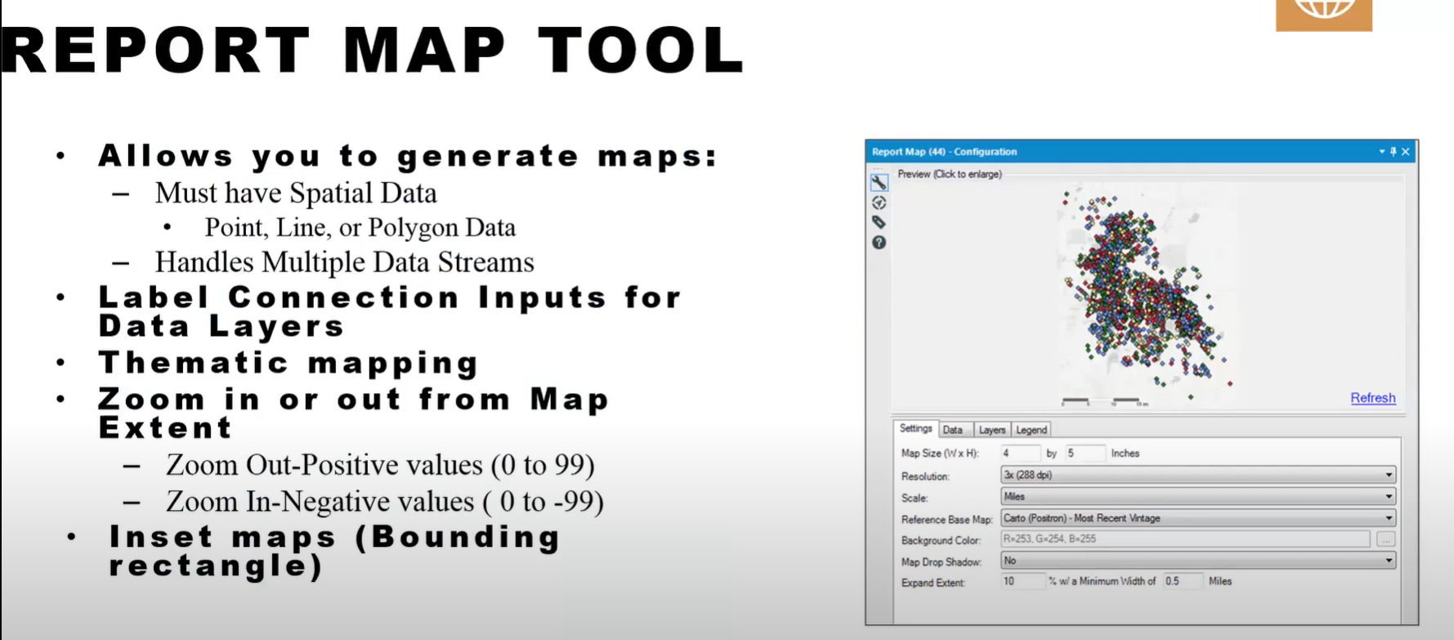

* [Reporting]

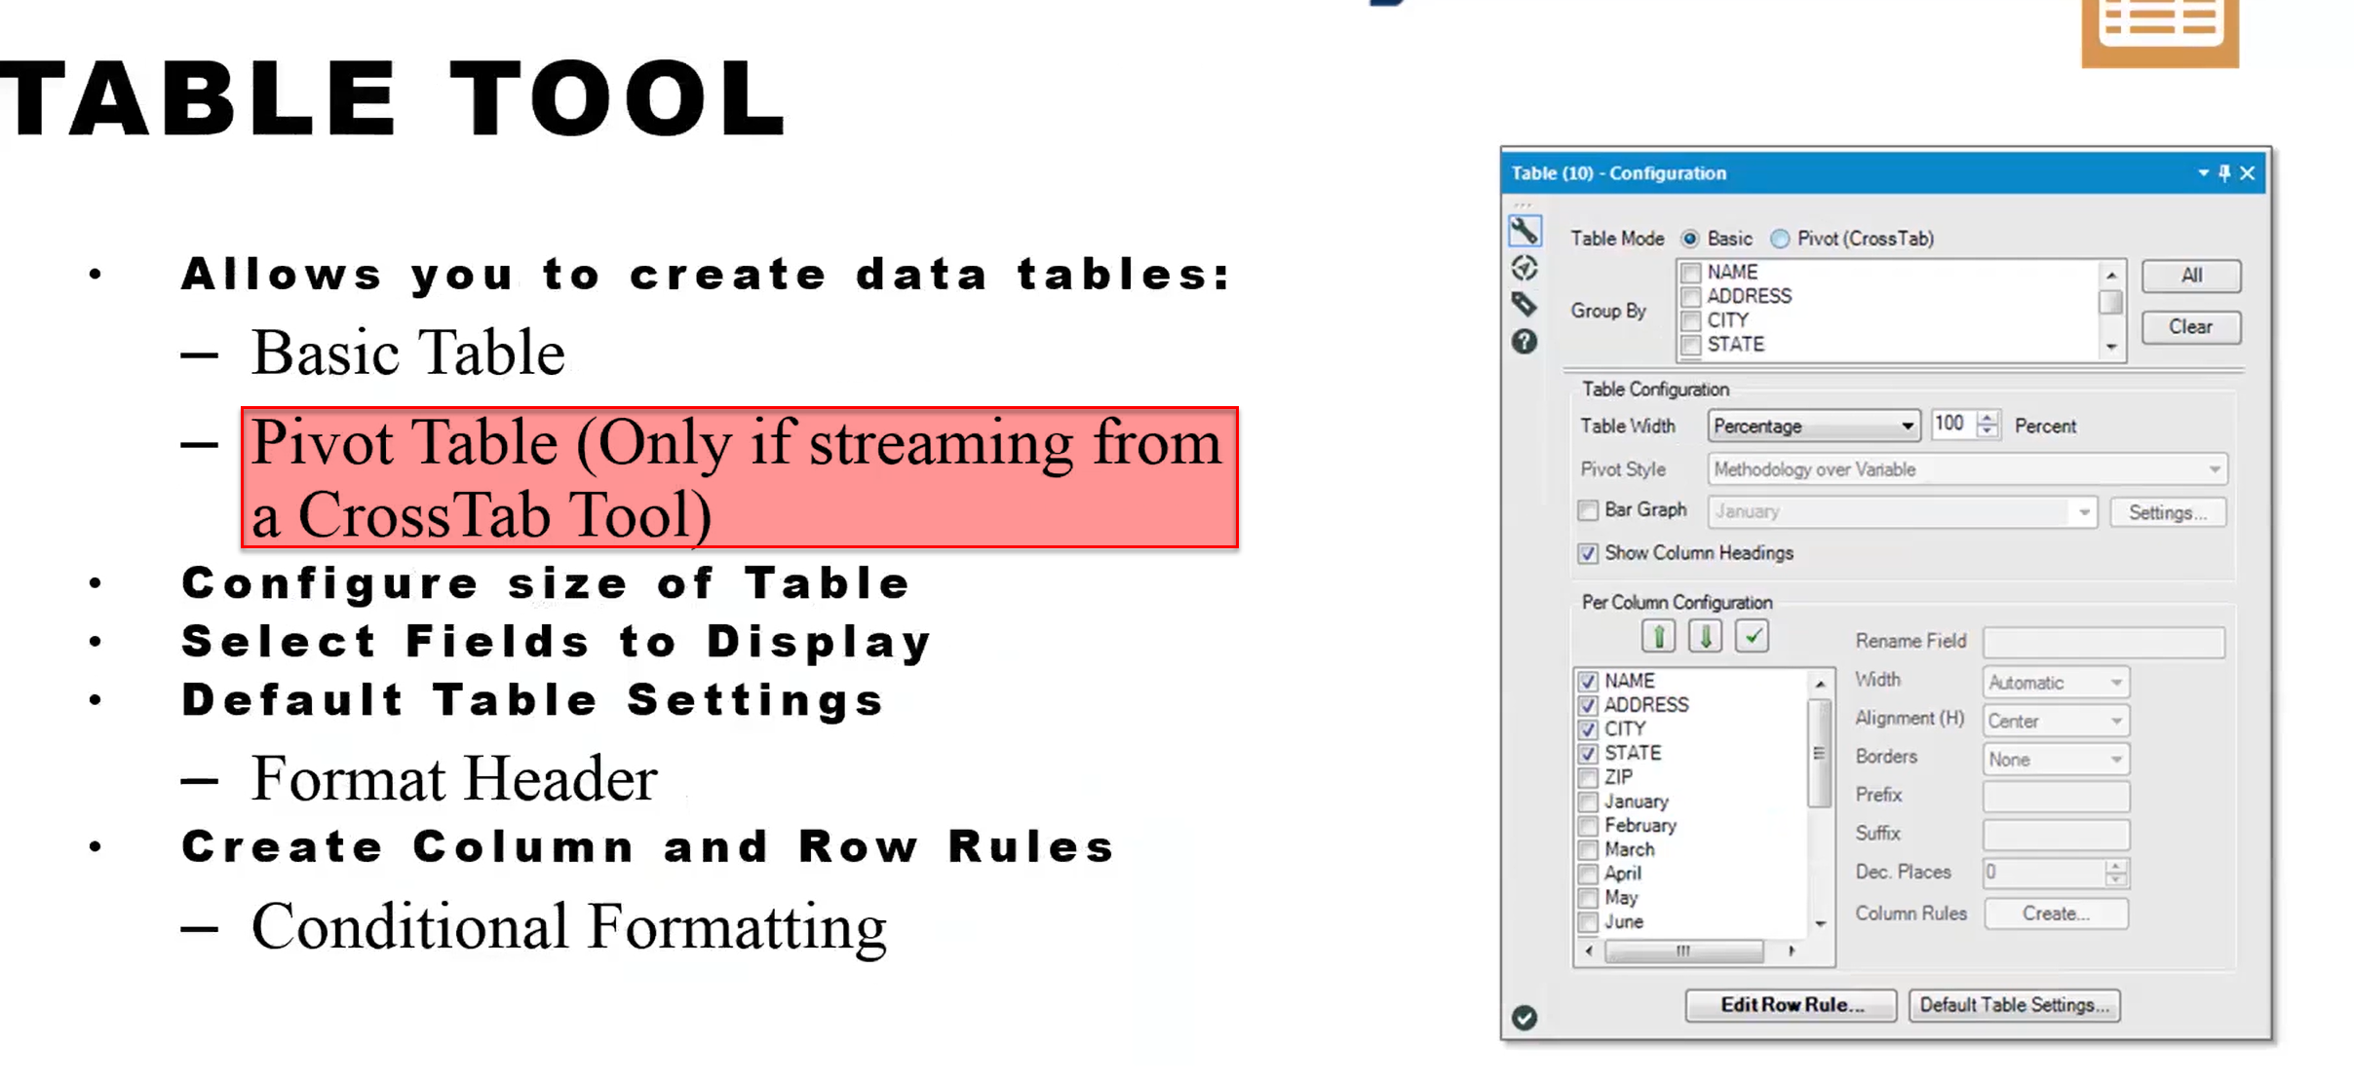

* [Reporting]

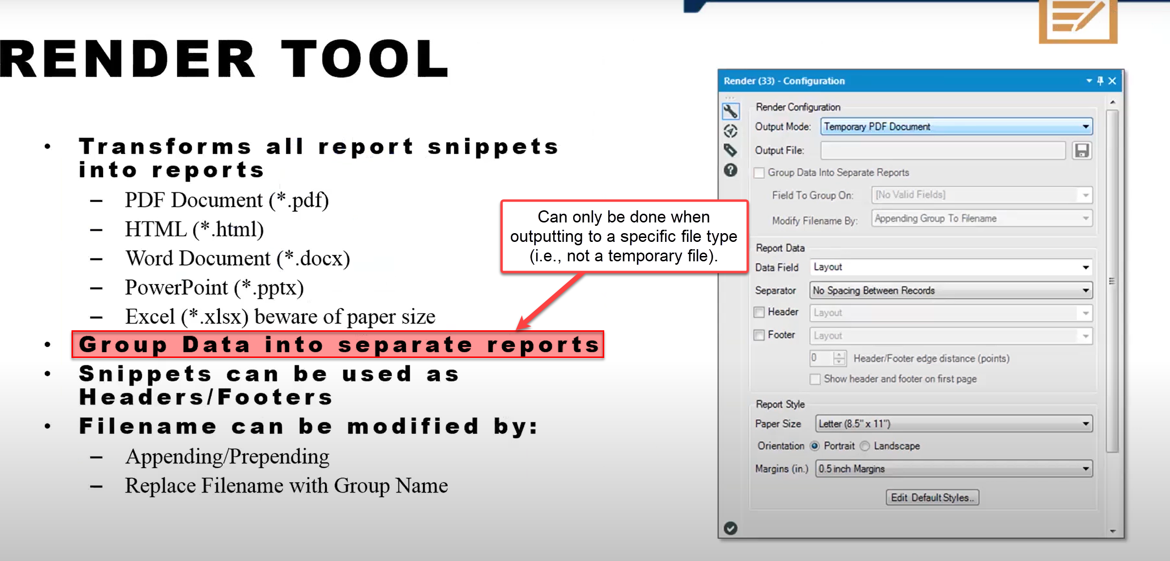

* [Reporting]

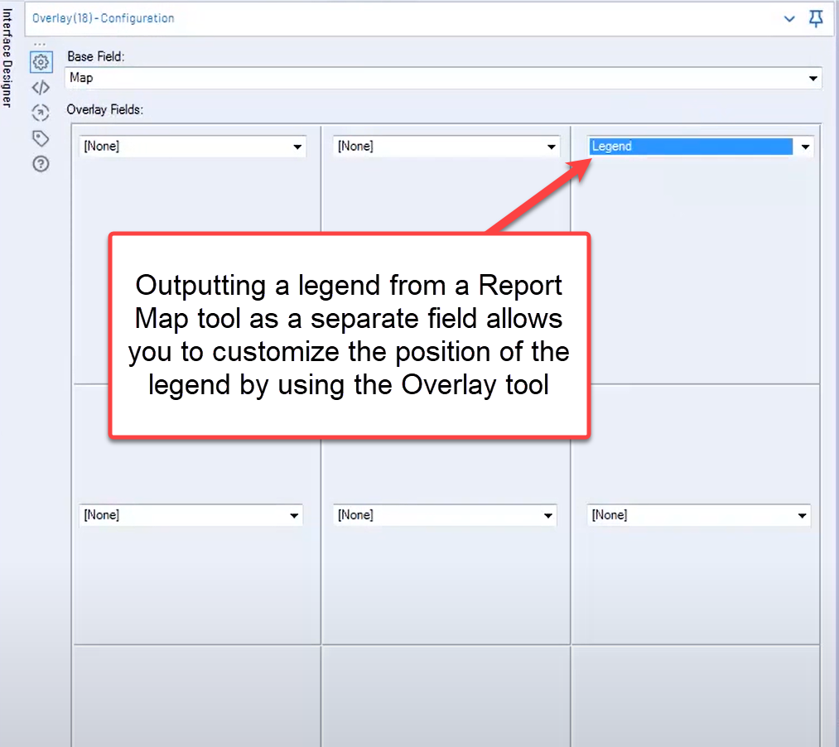

* [Reporting]



* [Spatial]

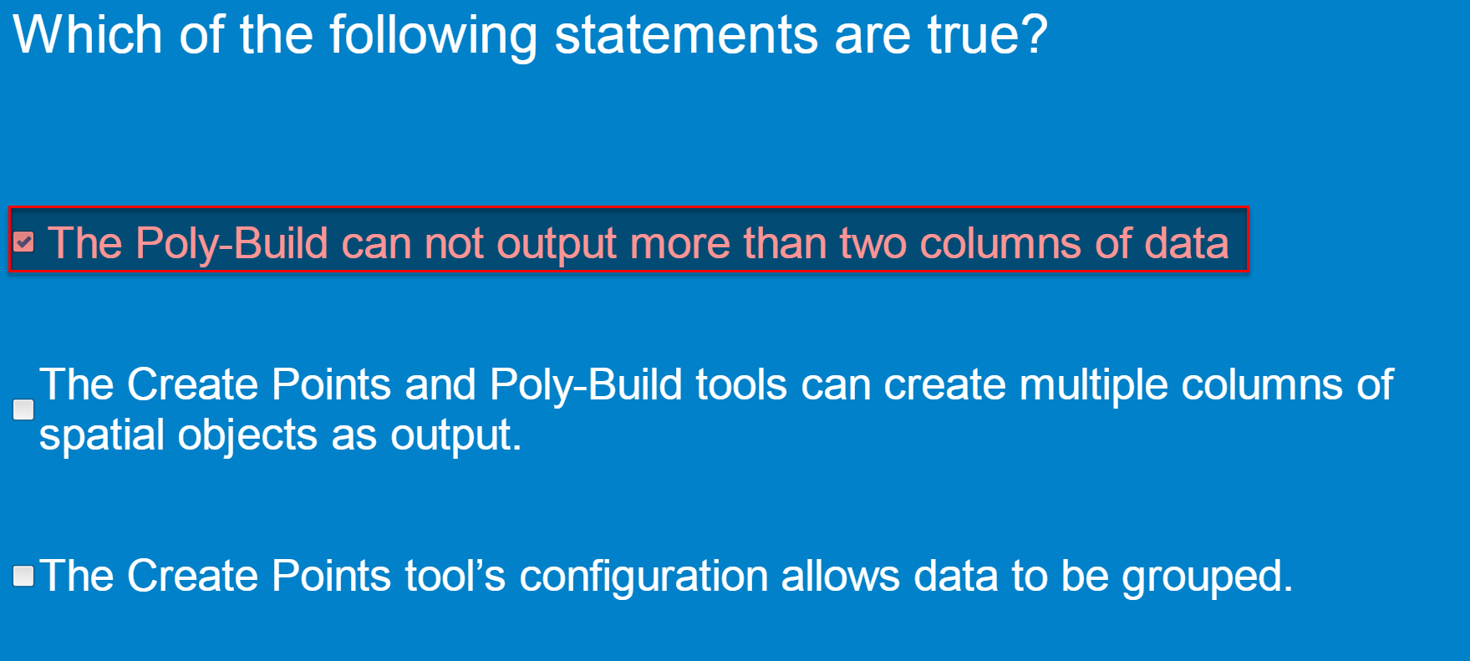

* [Data Investigation]



* [Data Investigation] Field Summary tool

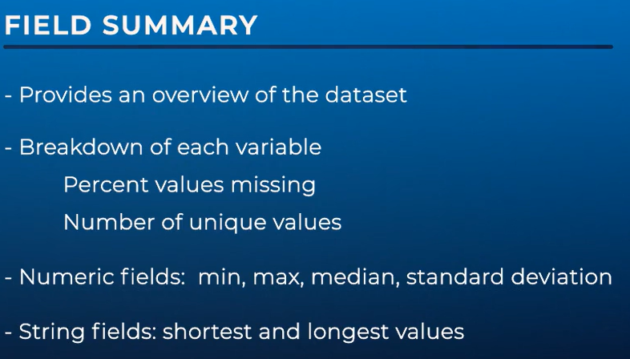

* [Data Investigation] Scatterplot tool

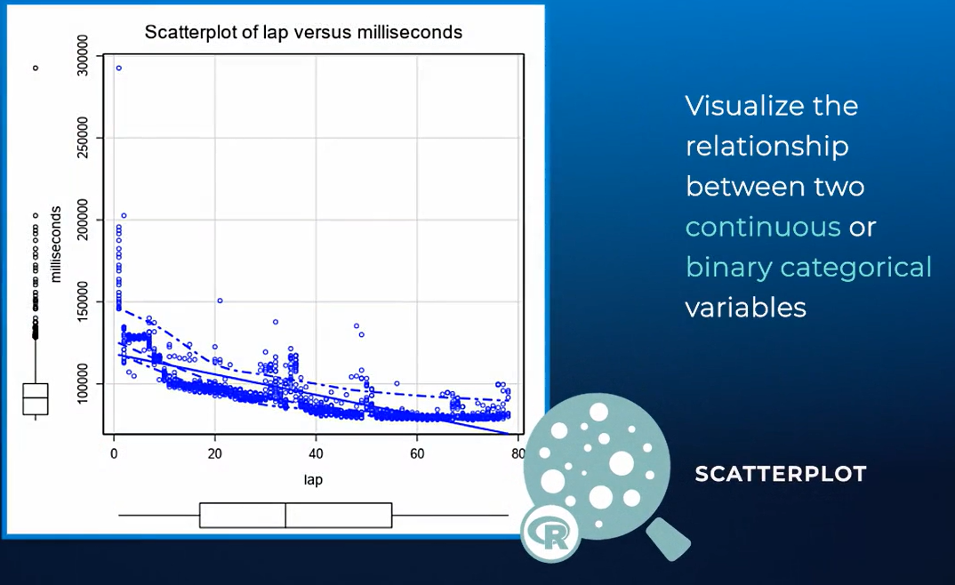



* [Data Investigation] Spearman Correlation tool

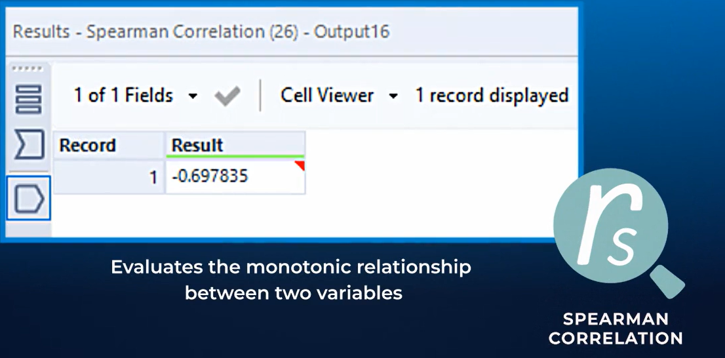

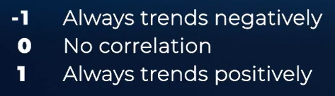





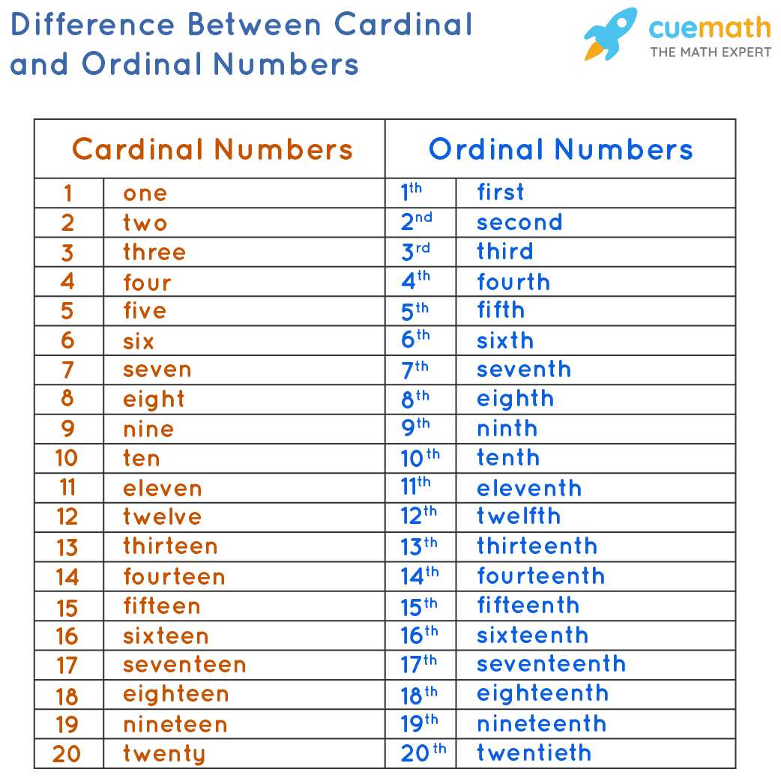

* [Data Investigation] Frequency Table

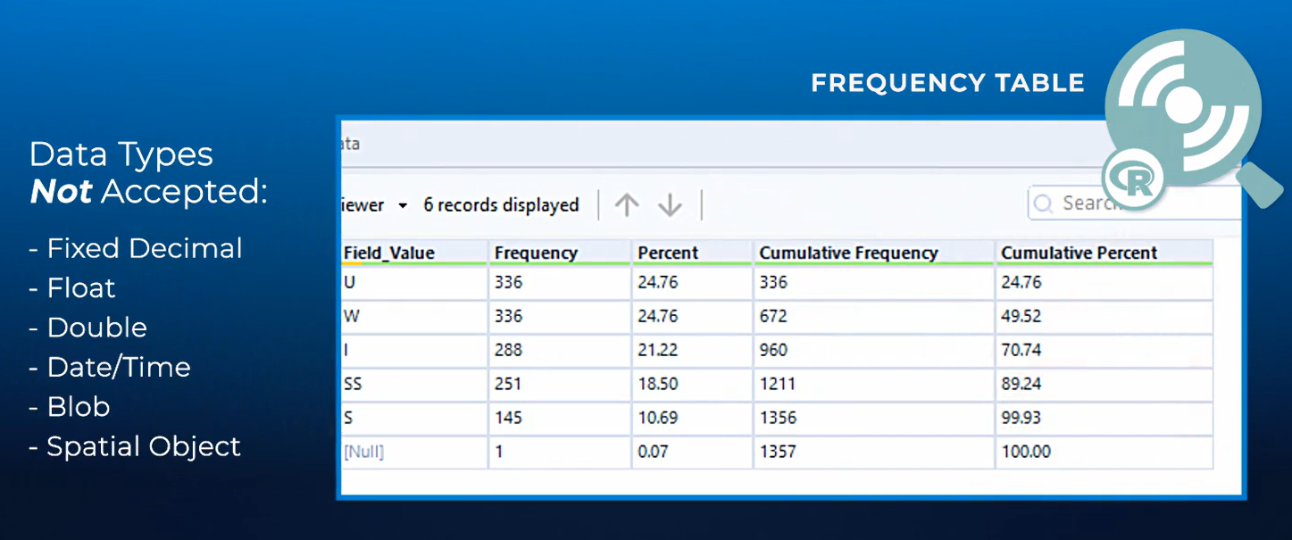

* [Data Investigation]

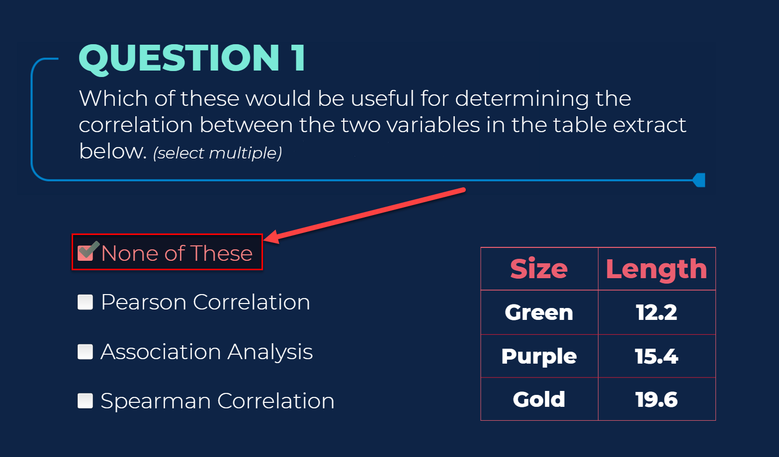

* [Data Investigation] General information

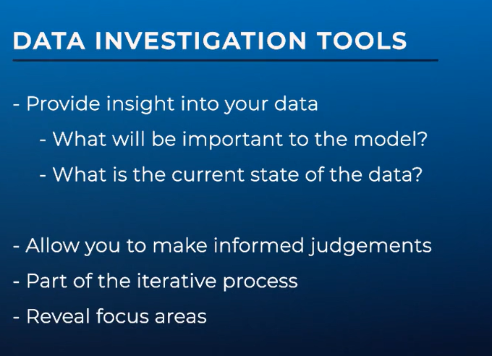

* [Parsing]

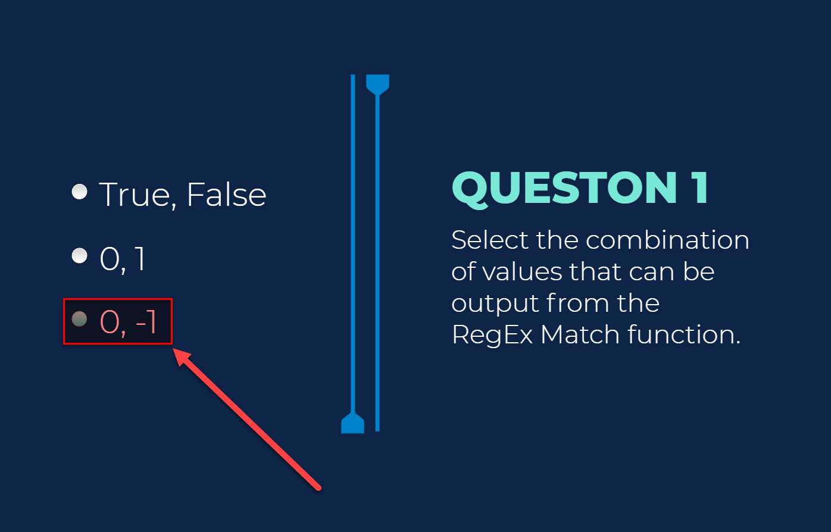

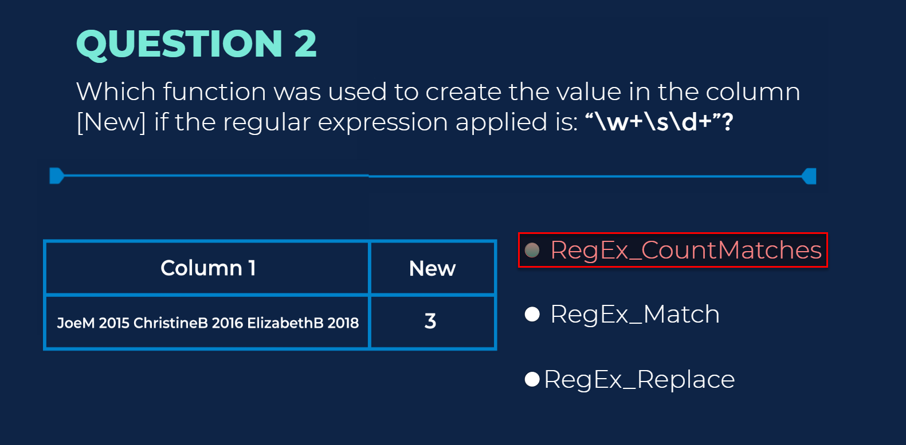

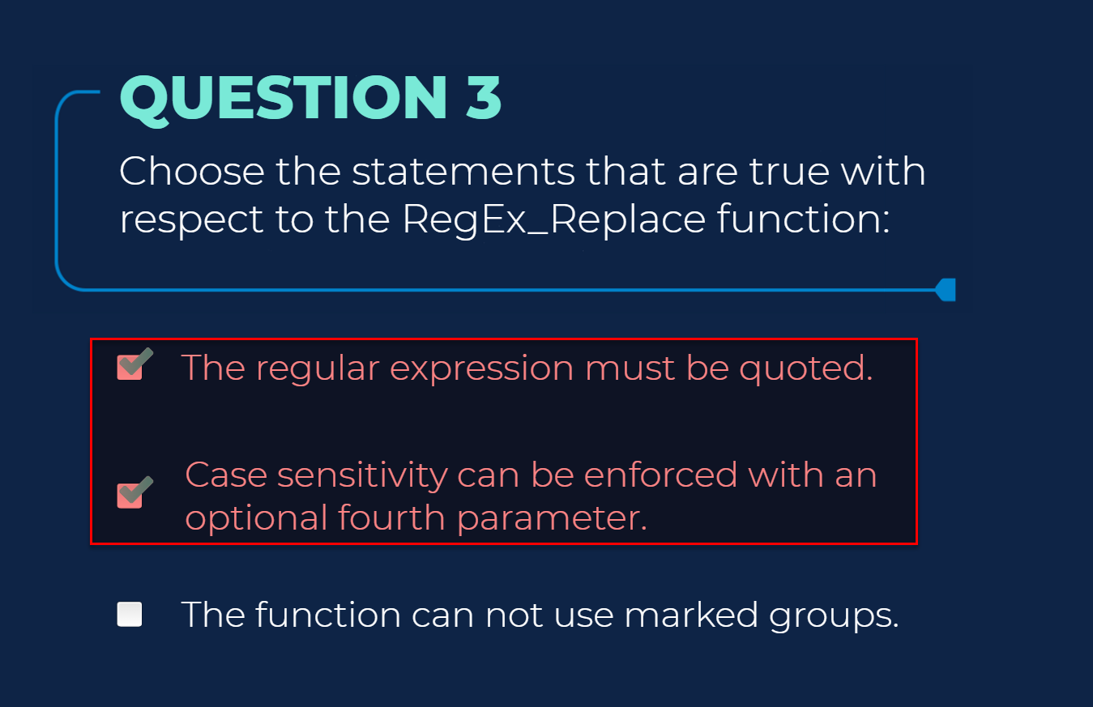

* [Macros]

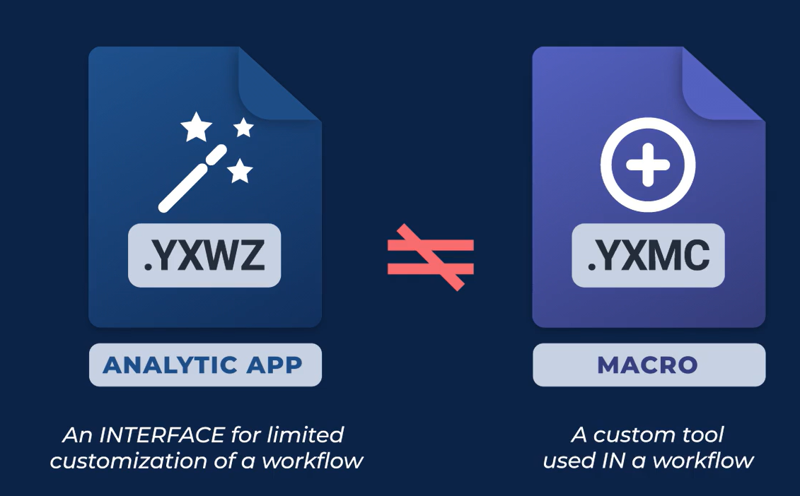

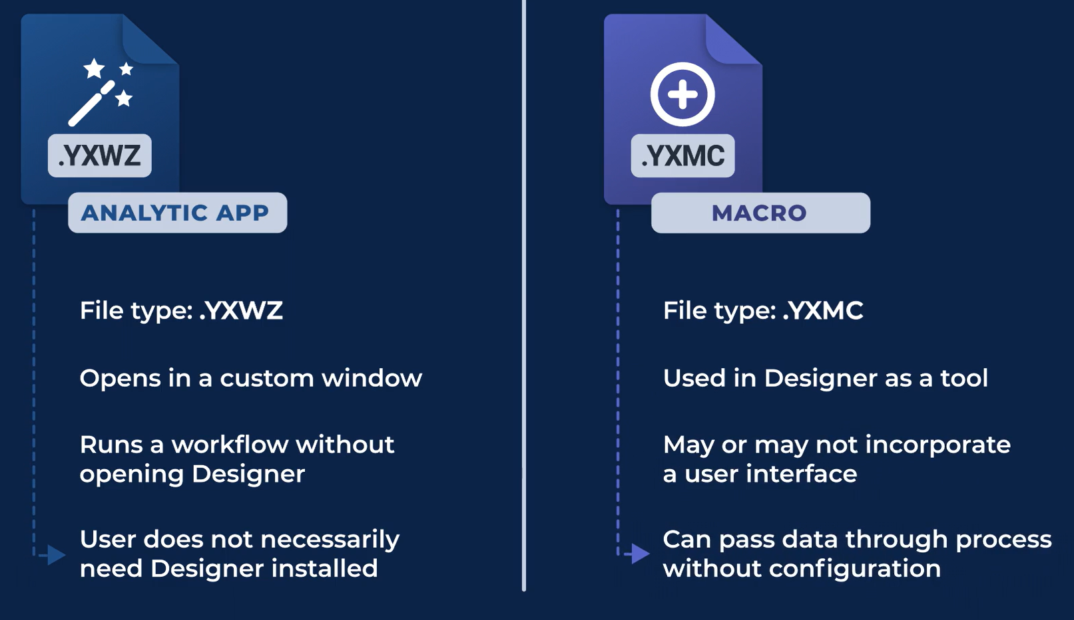

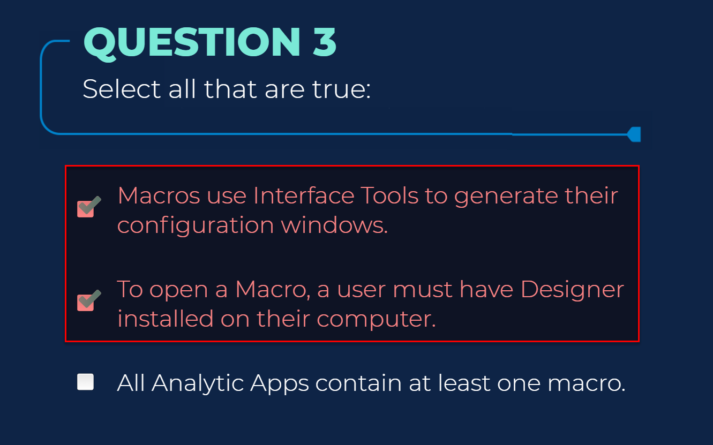



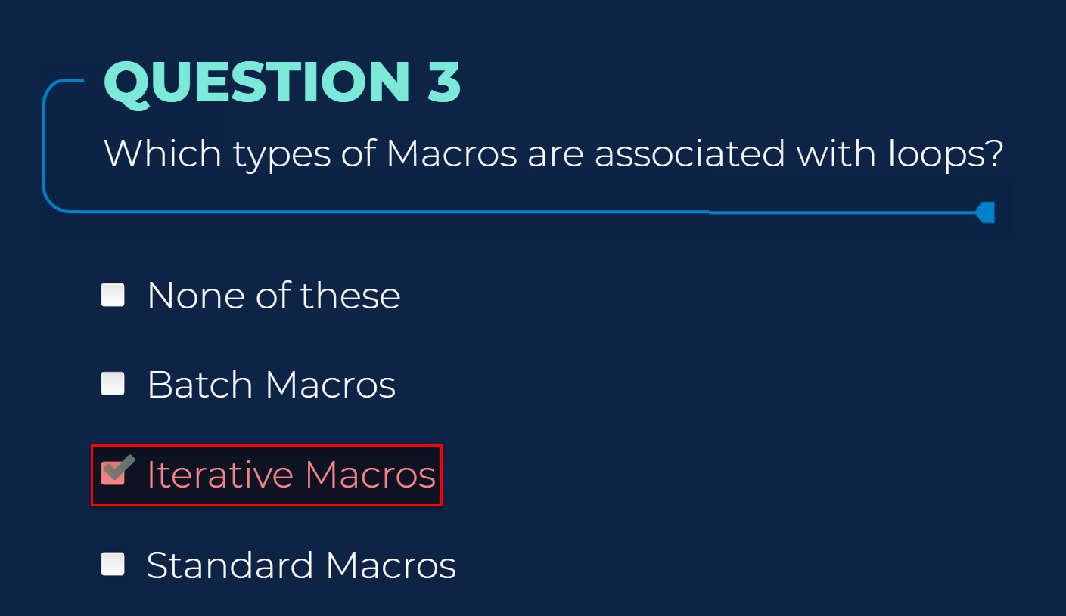

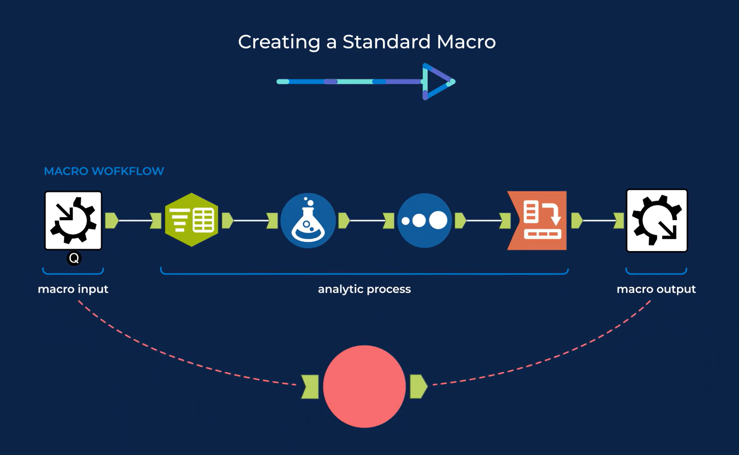

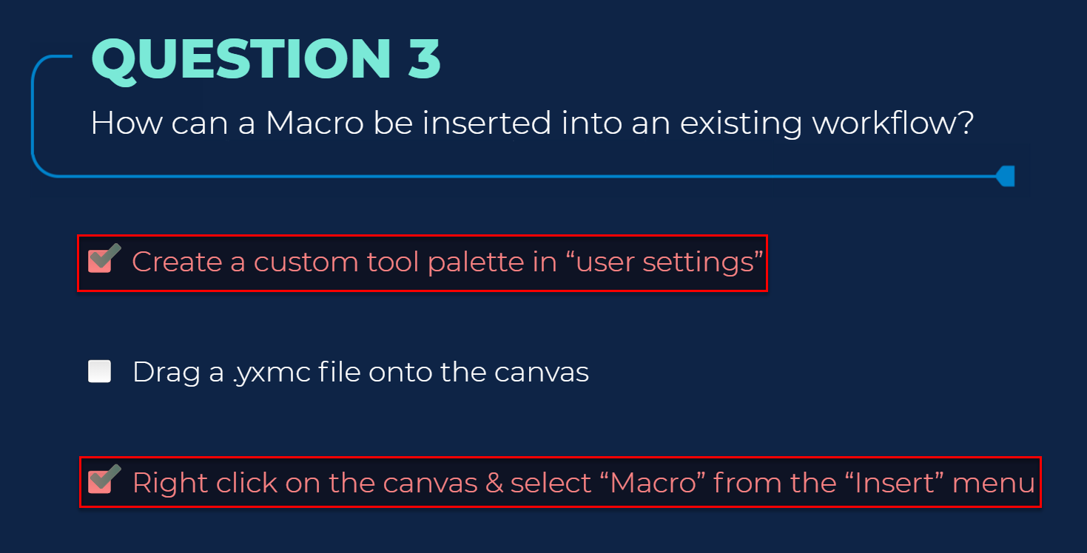

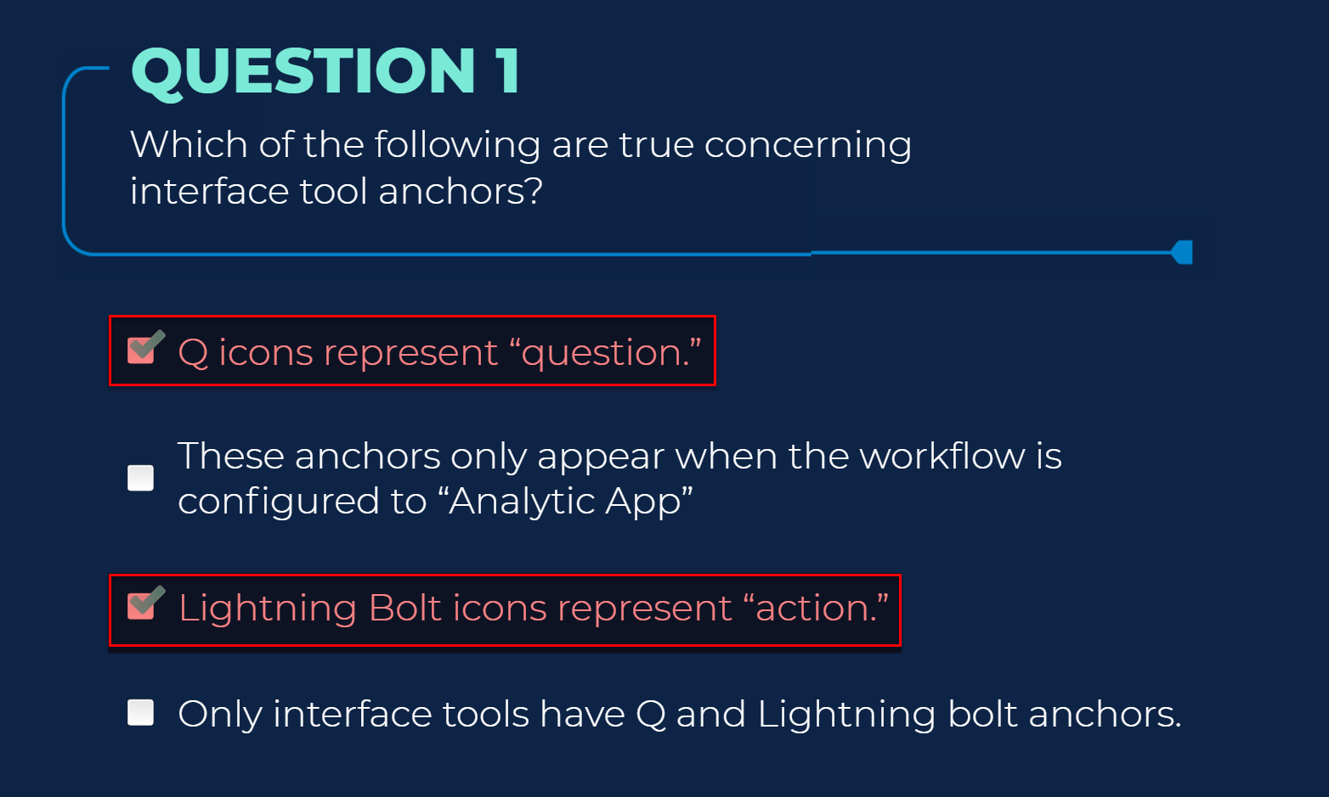



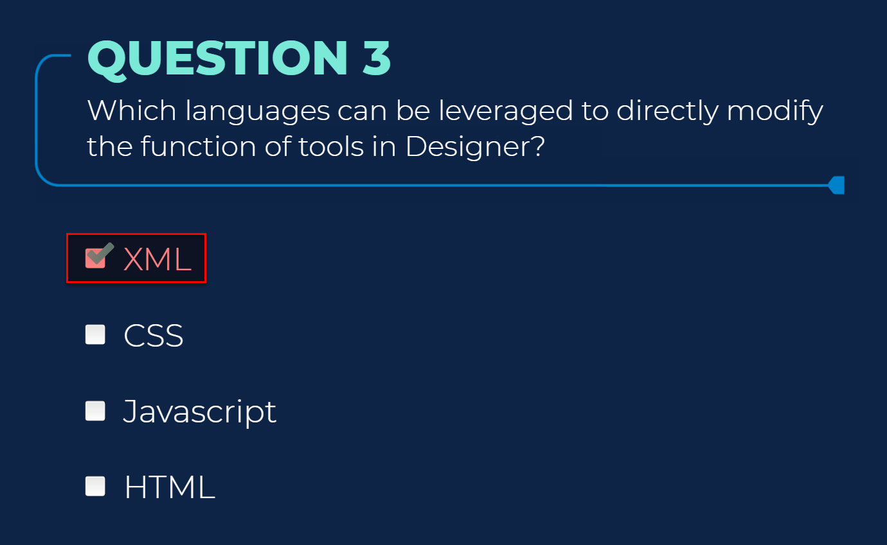

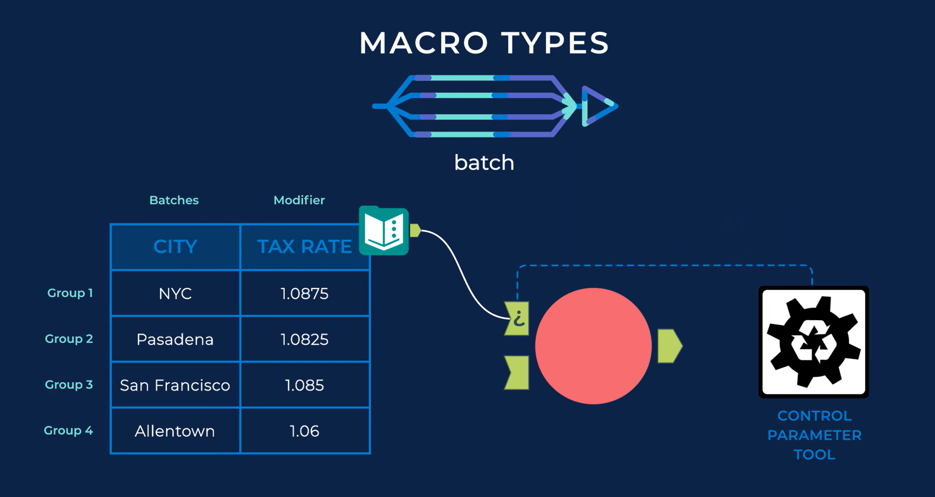

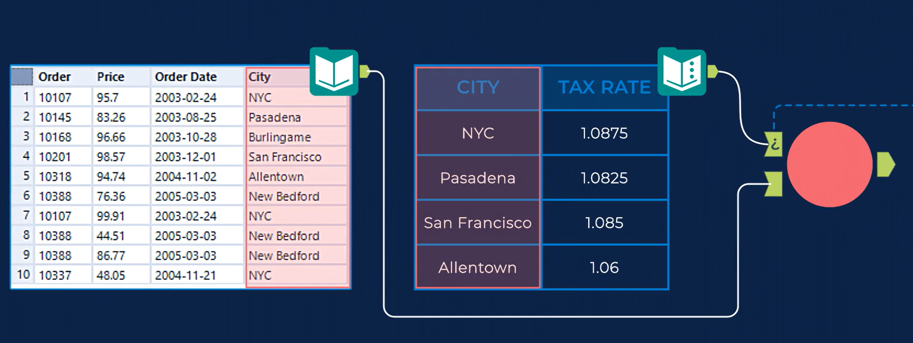

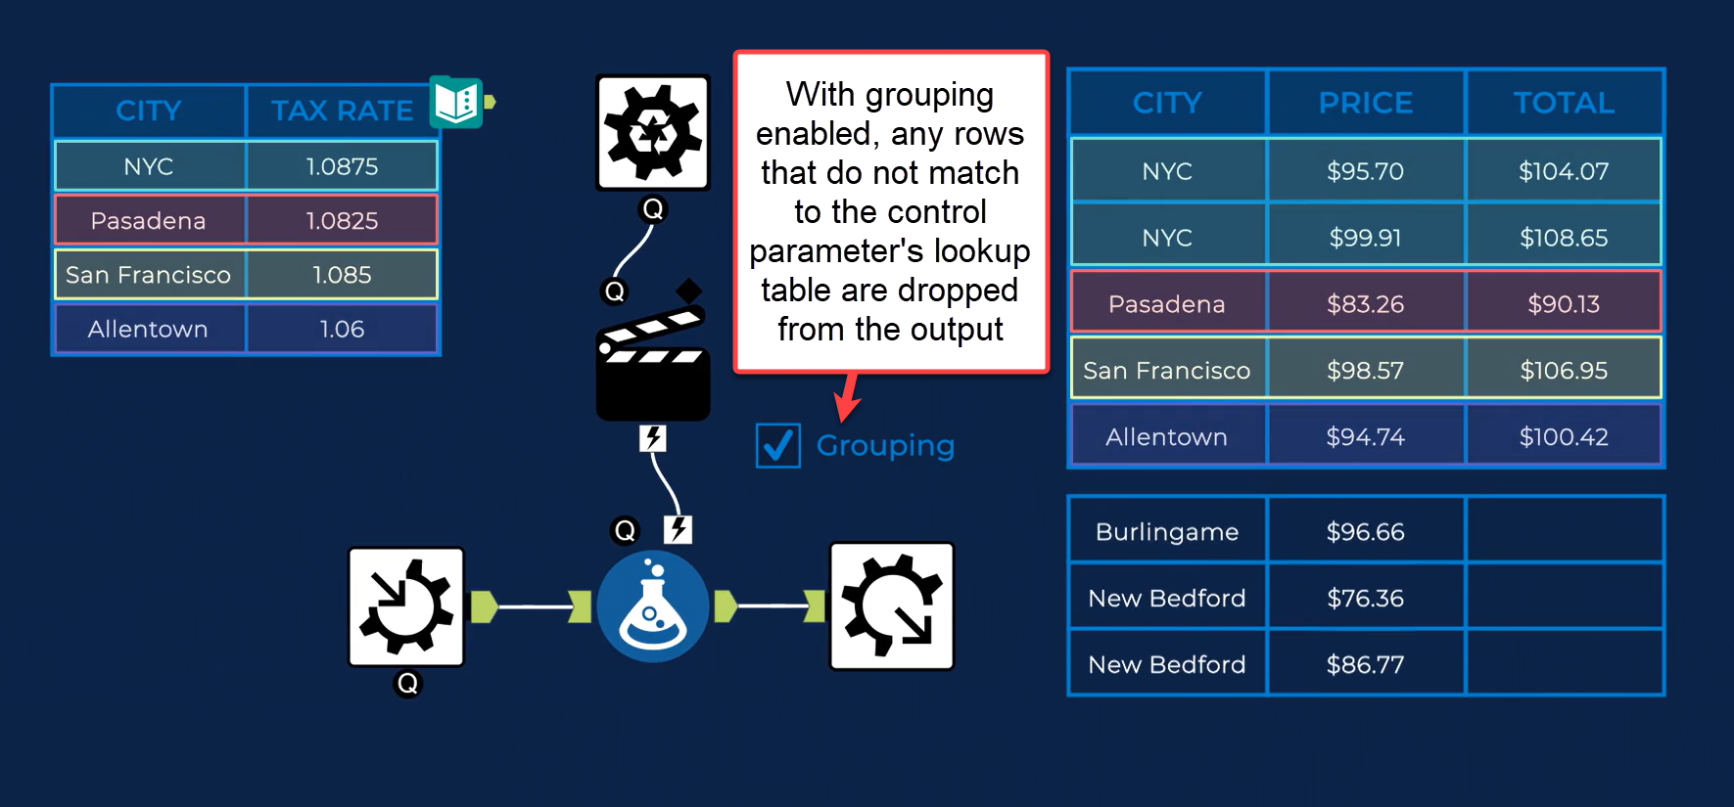

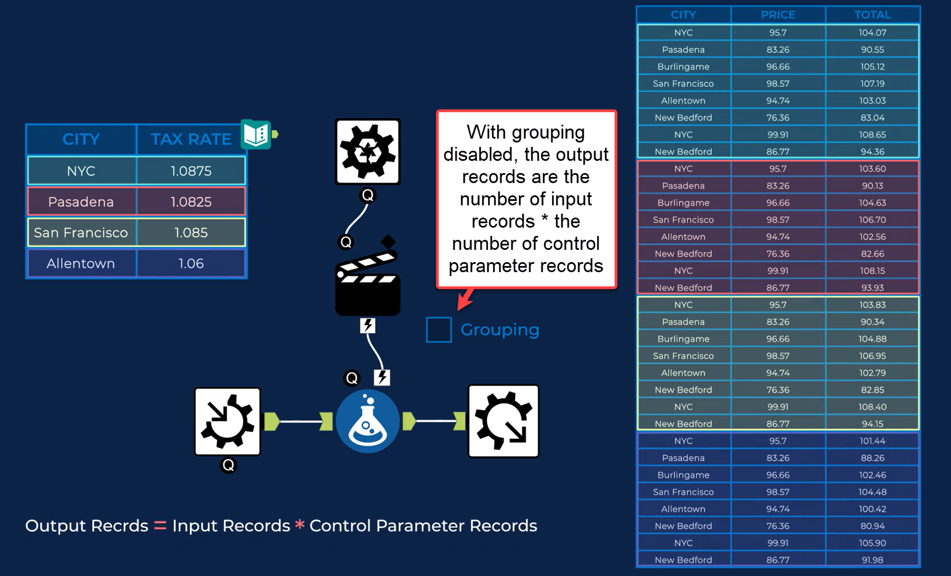

* [Analytic Apps] Q input and output

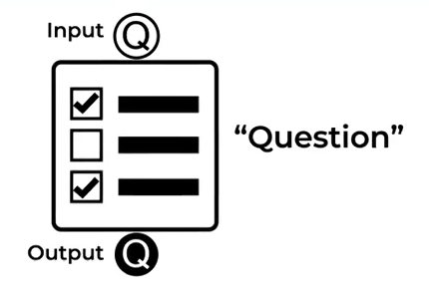

* [Macro] Relating to batch macros:

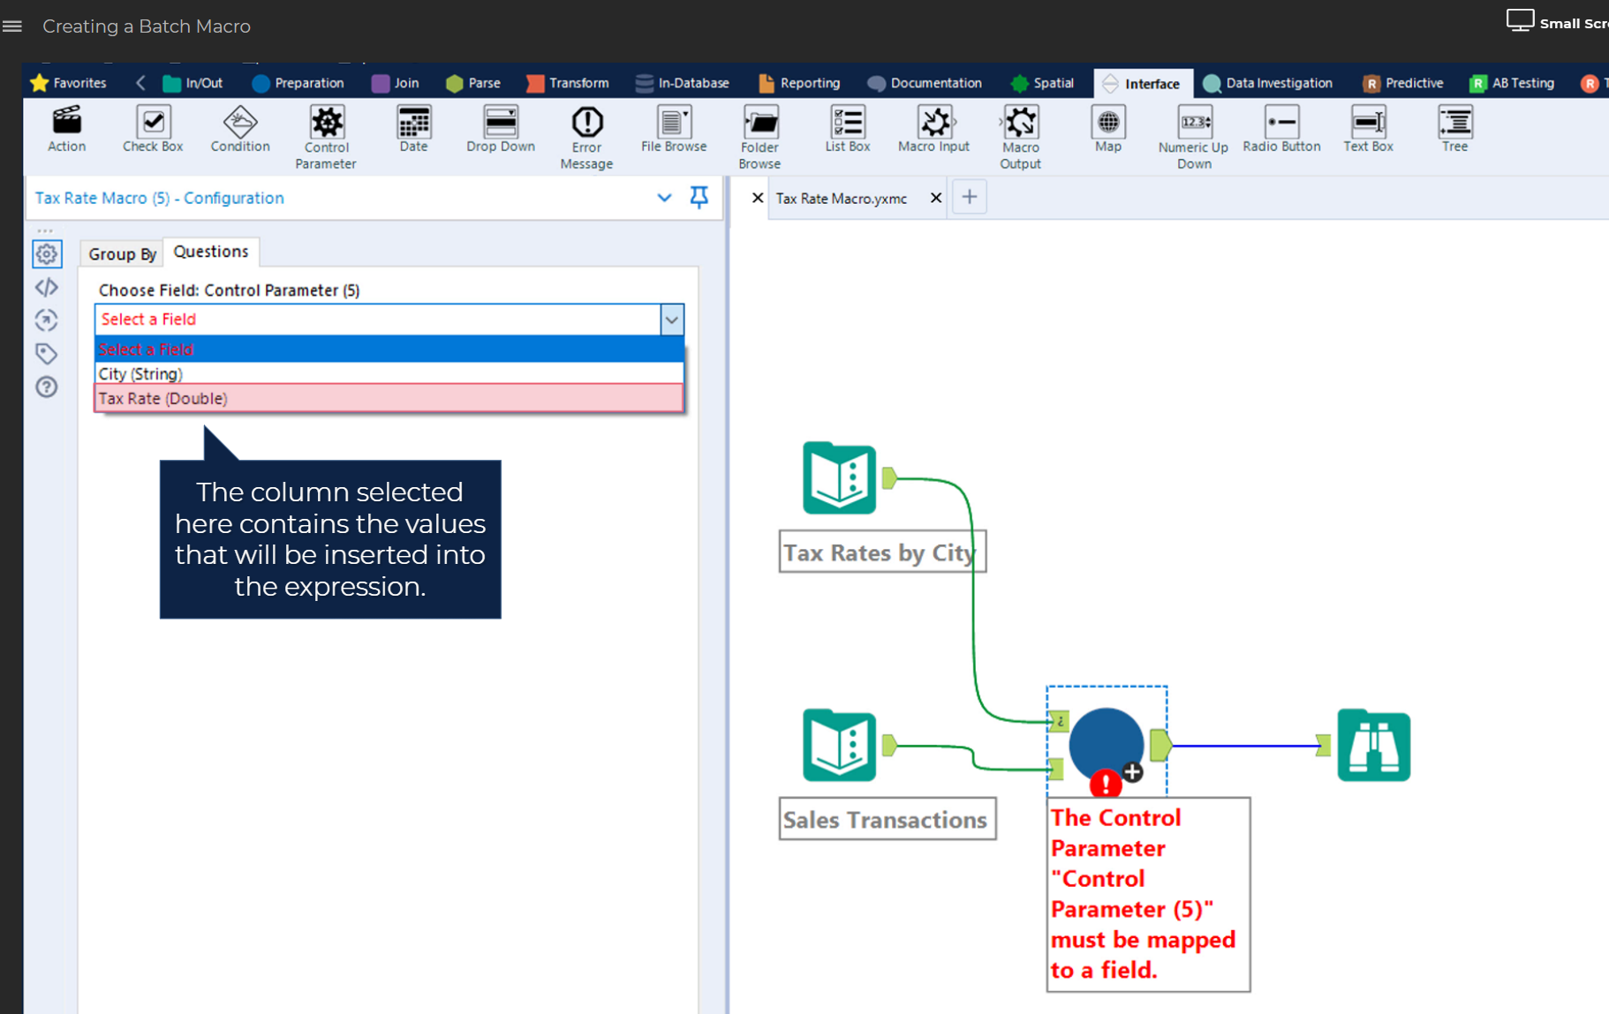

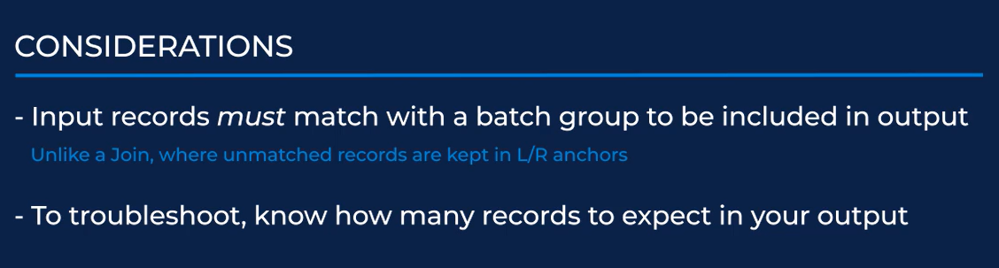

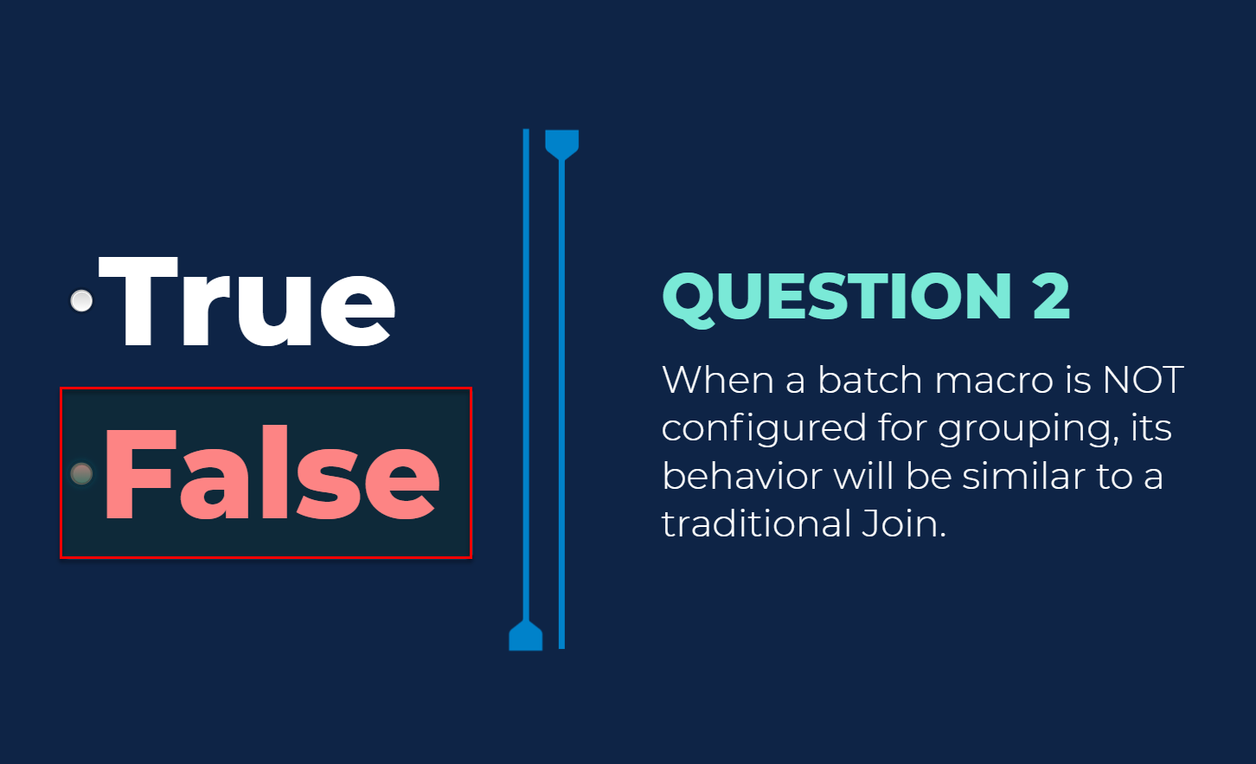

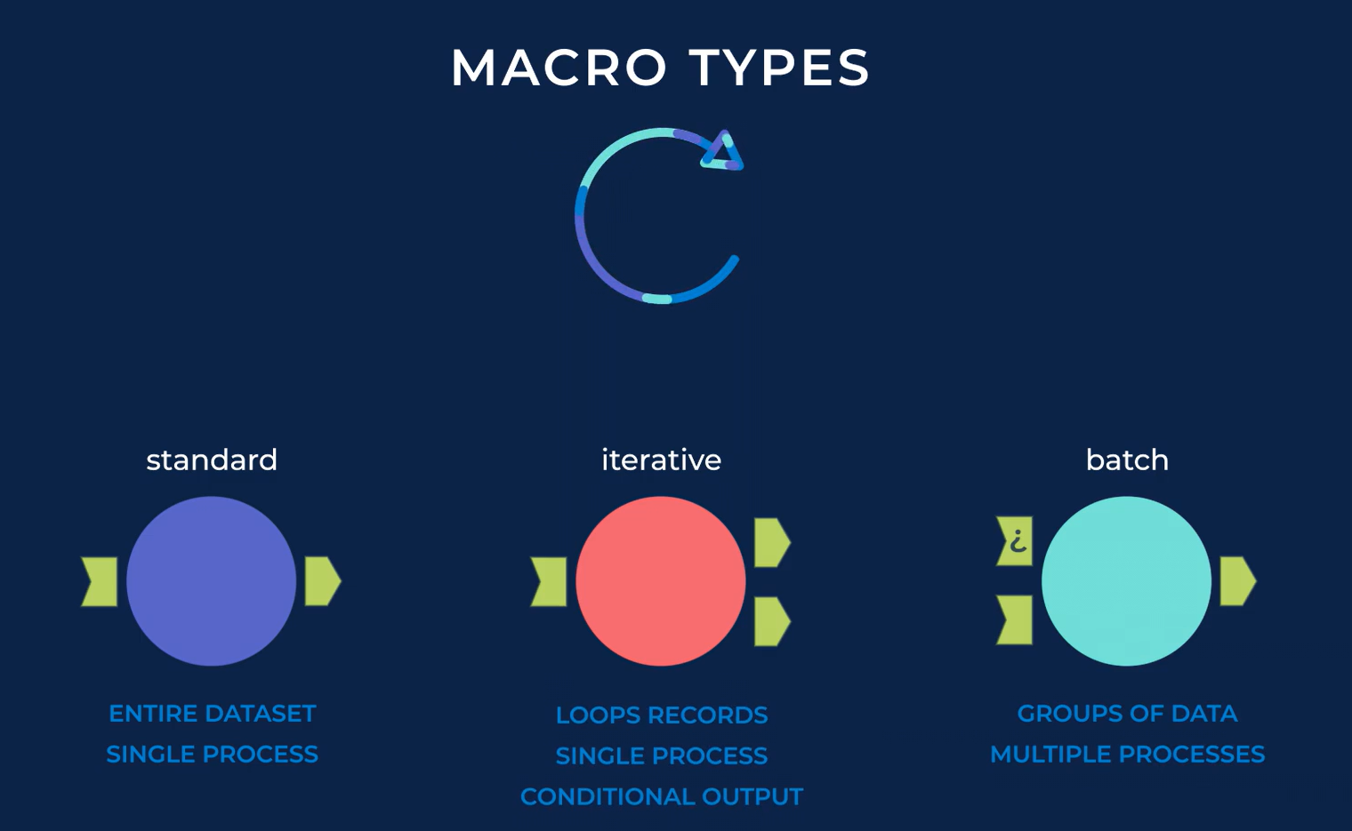

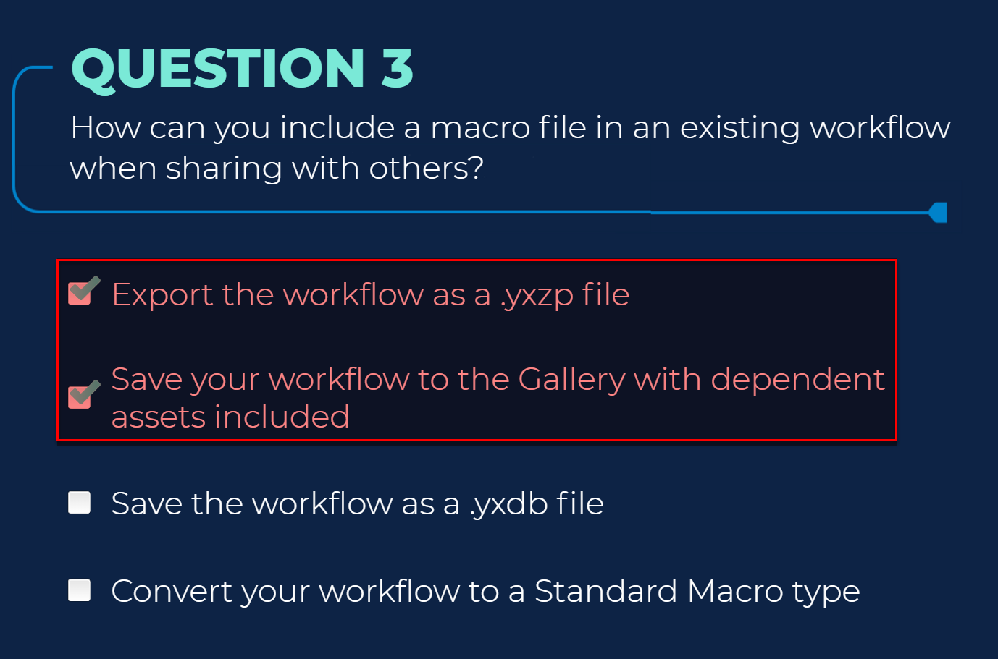

* [Analytic Apps]

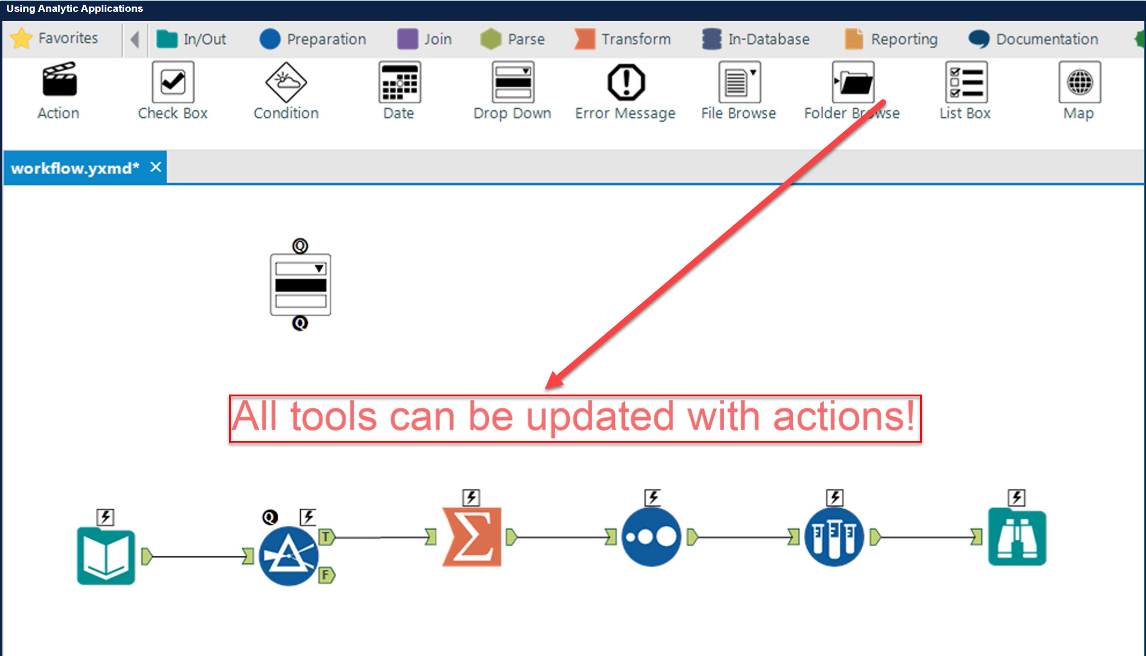

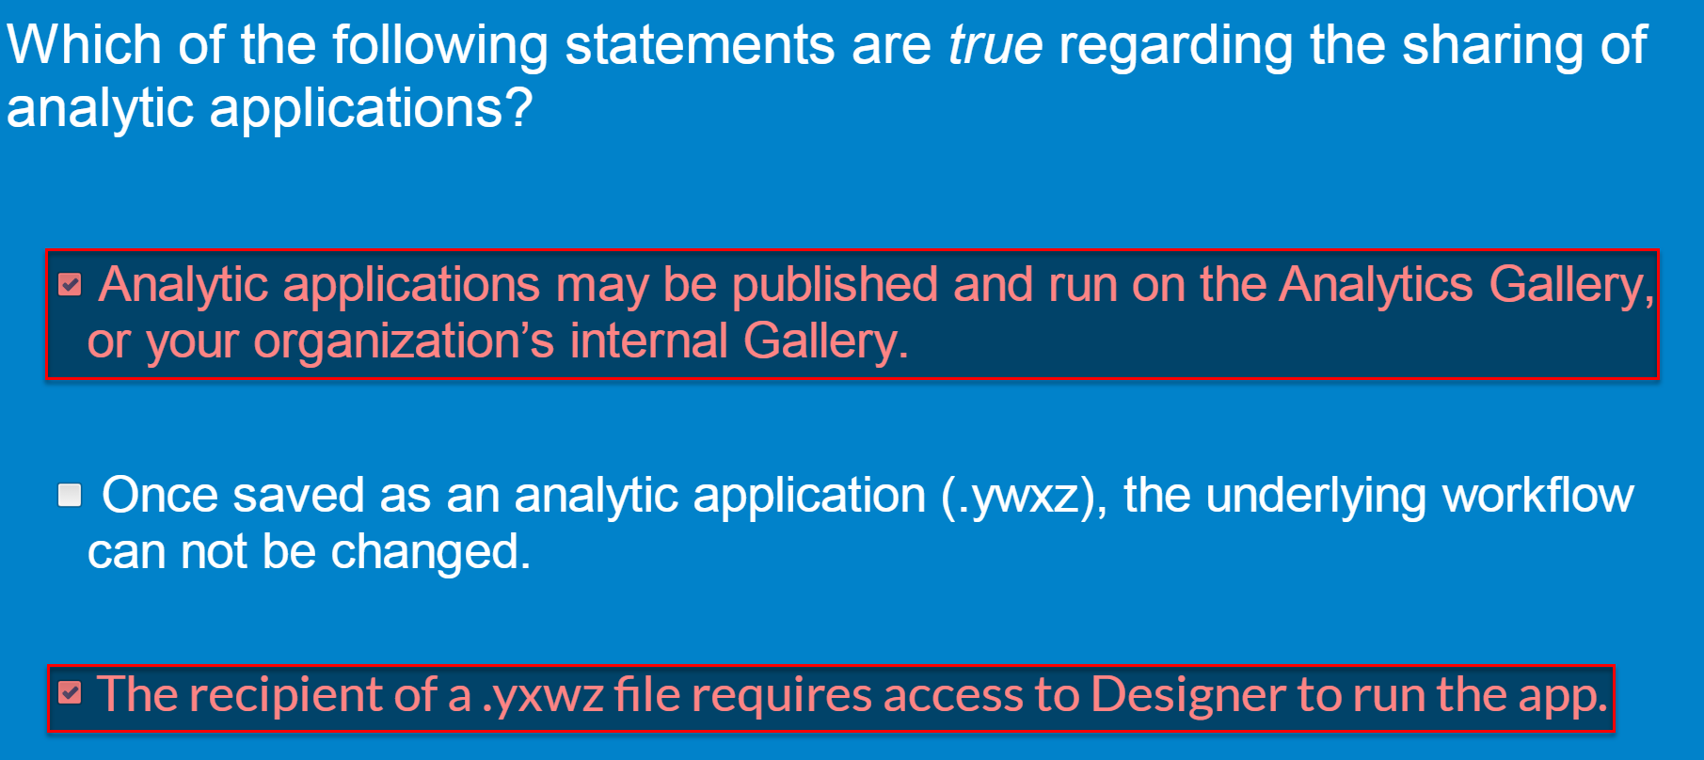

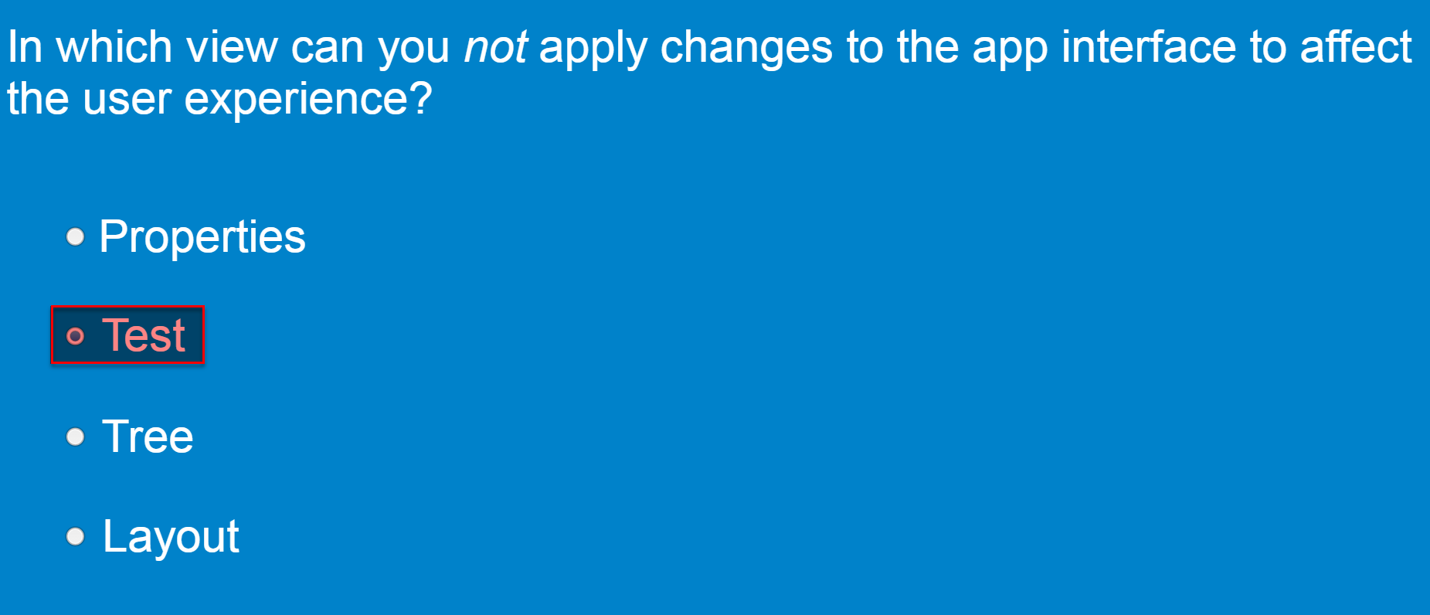

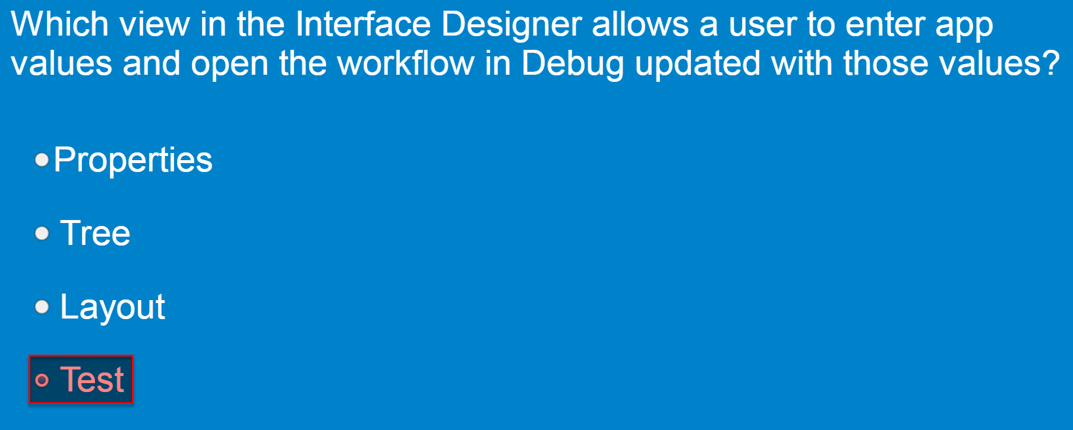

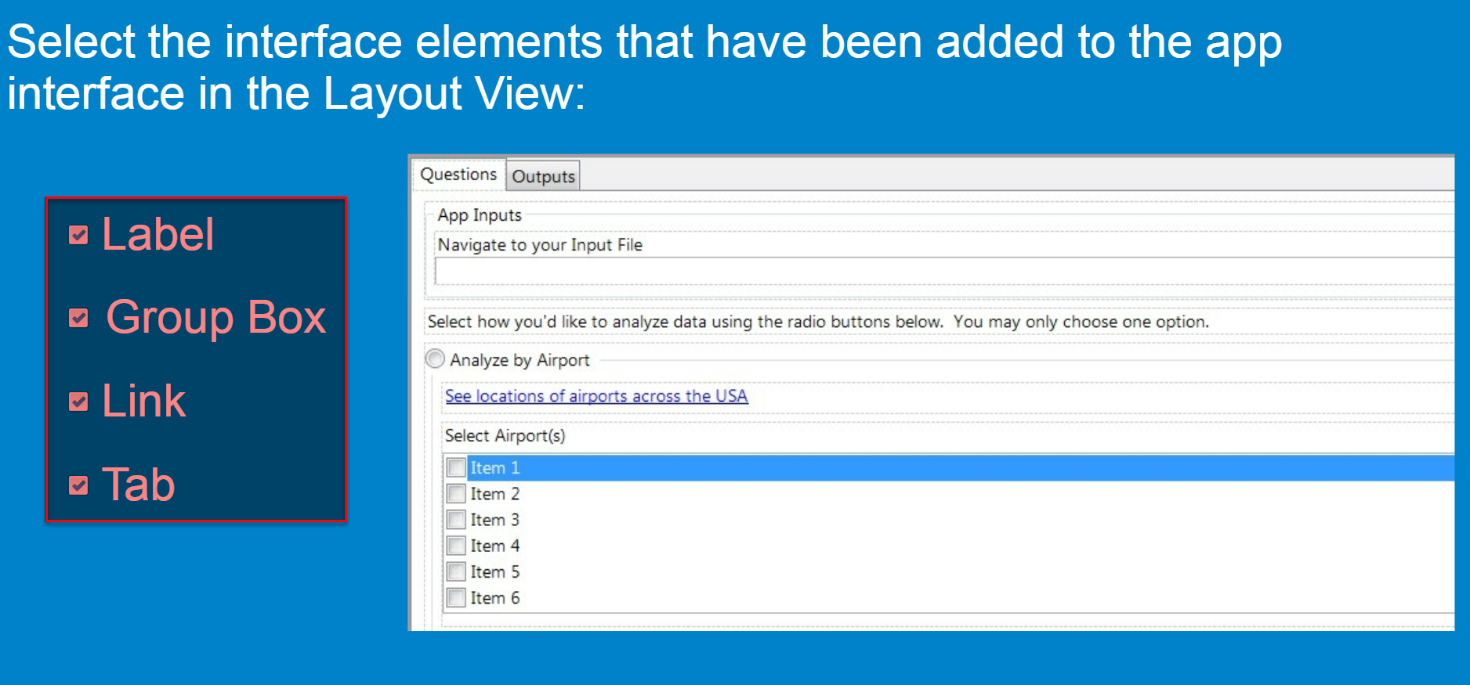

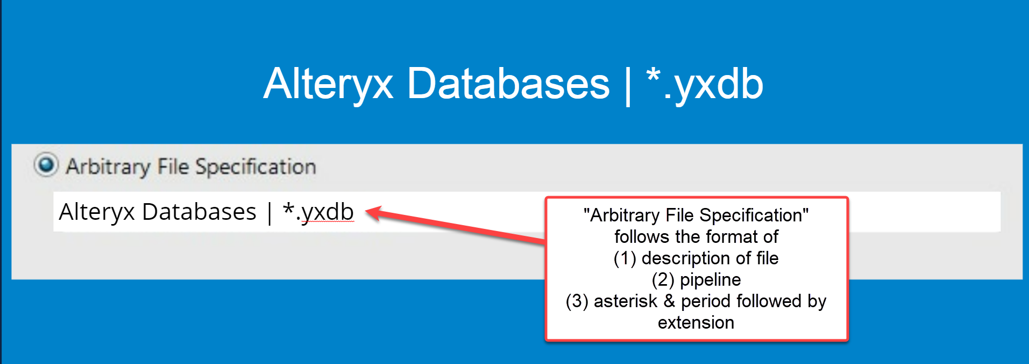

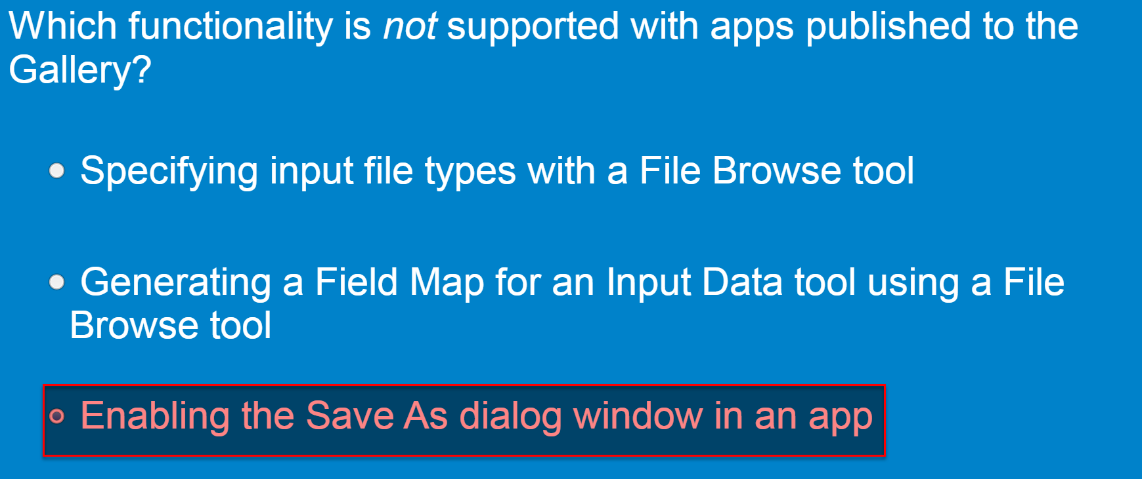

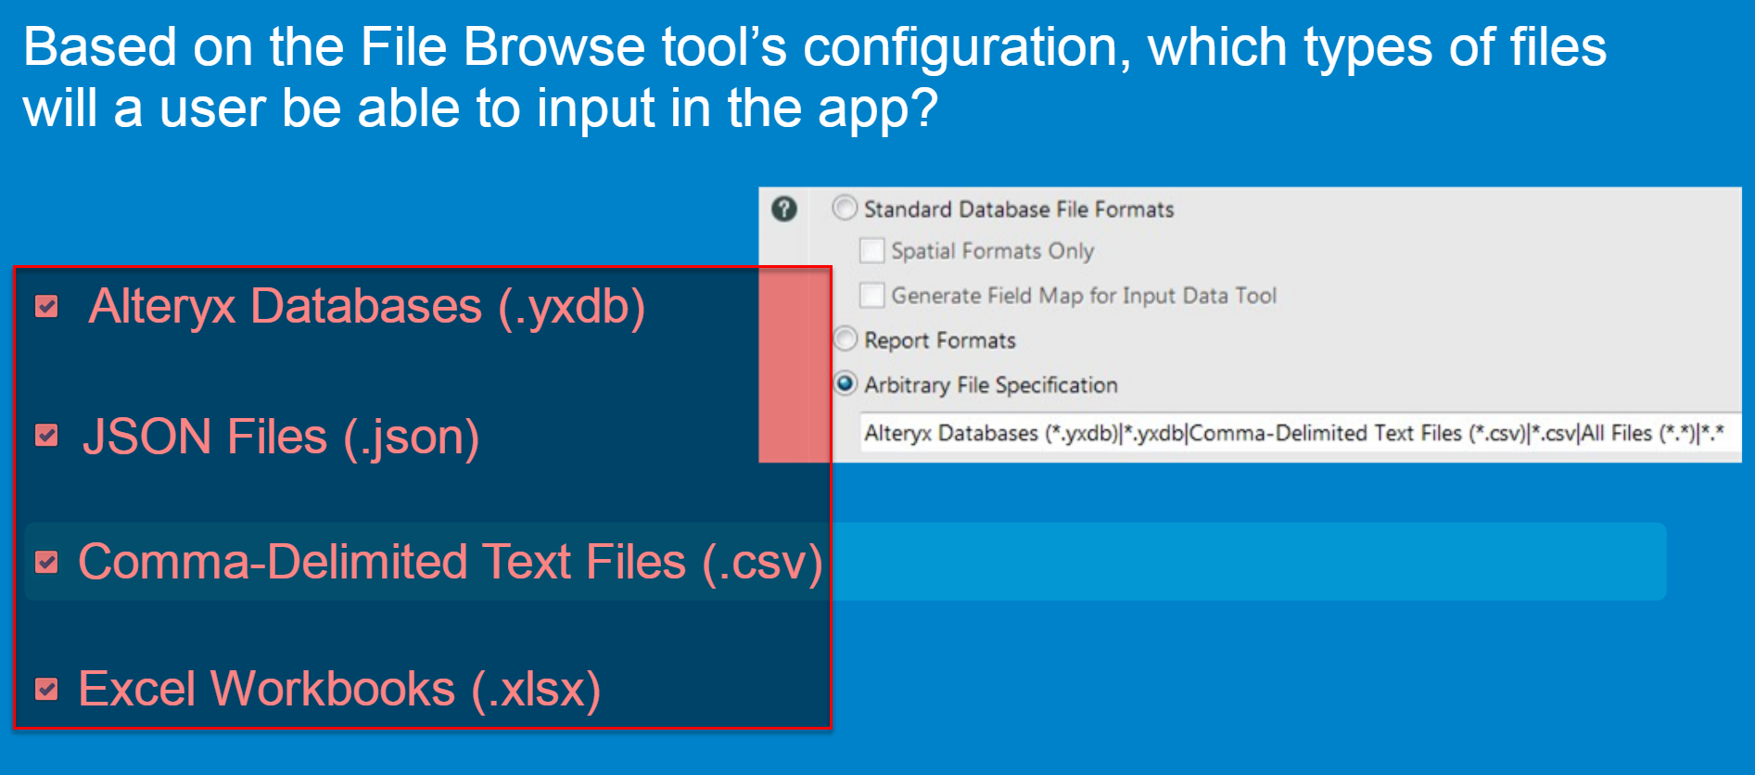

* [Analytic Apps]

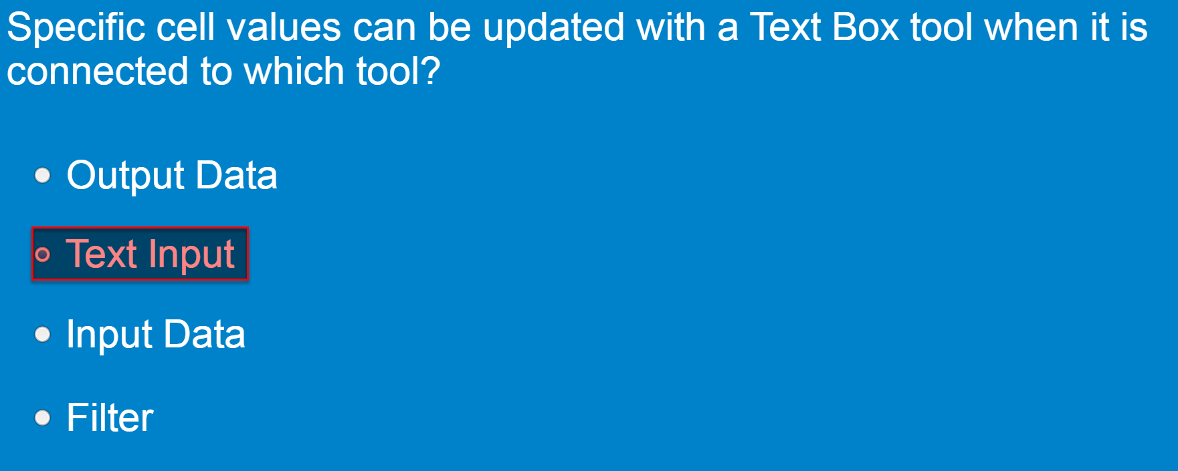

Example of this:

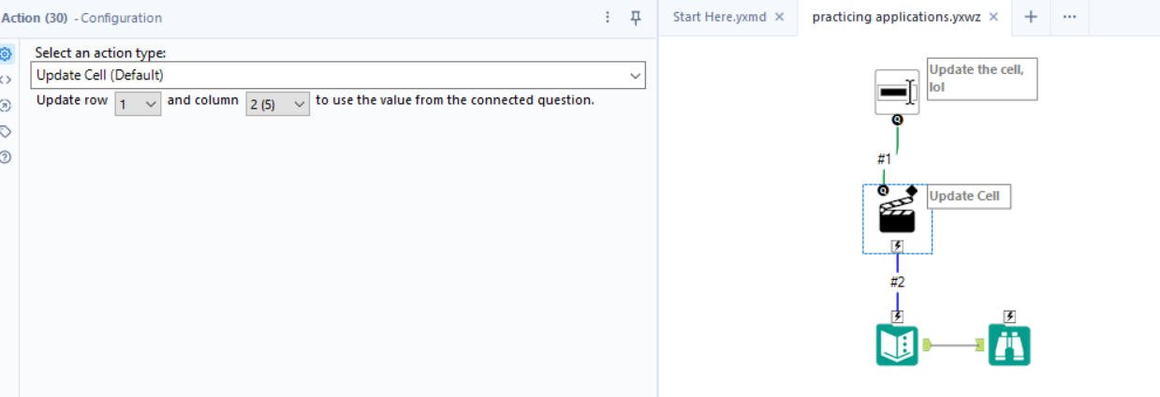

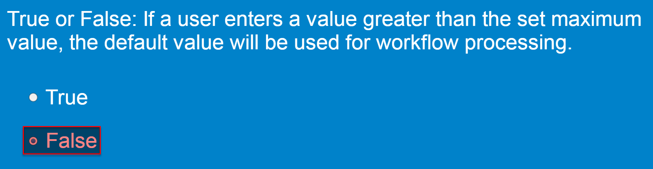

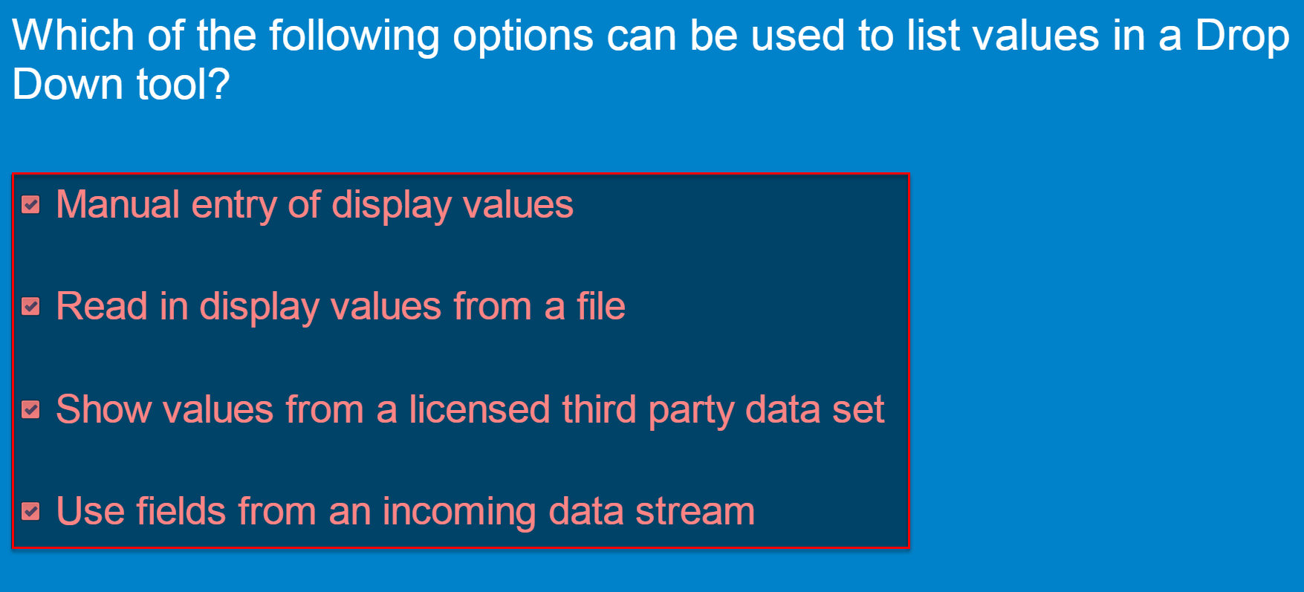

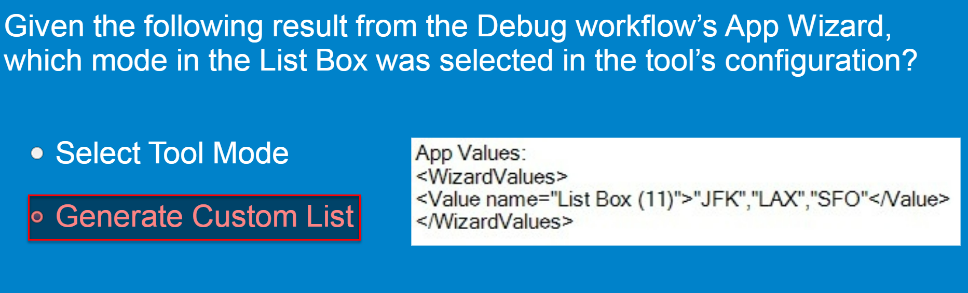

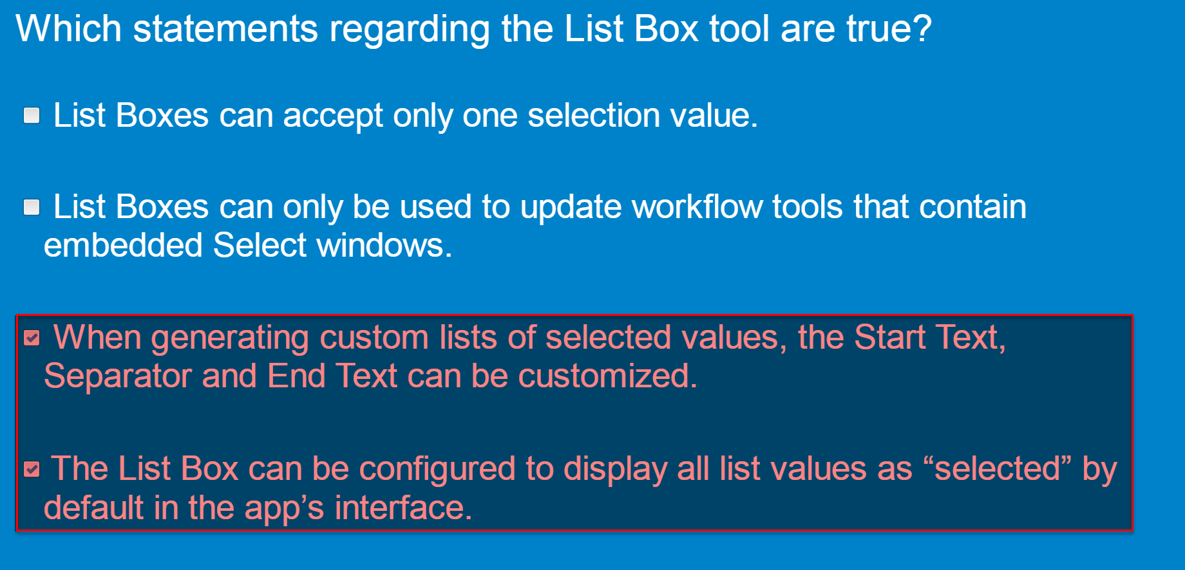

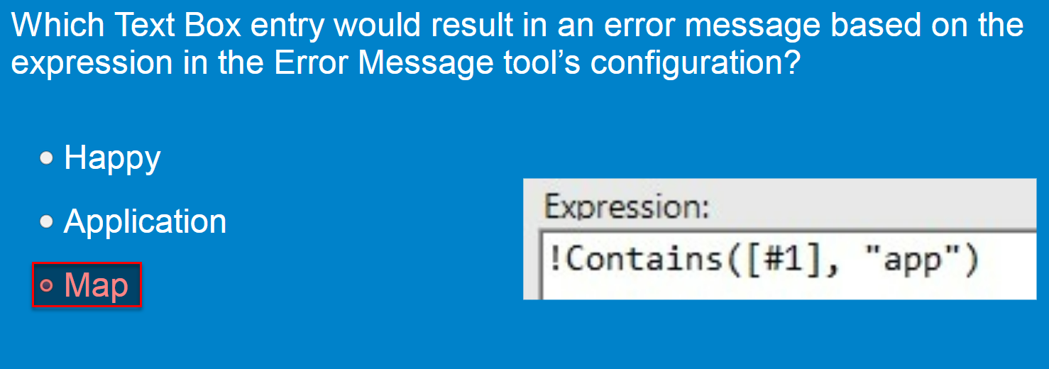

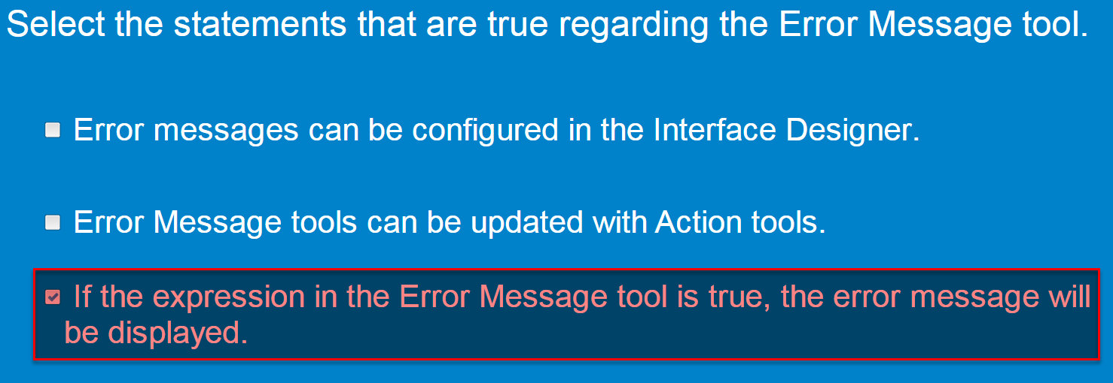

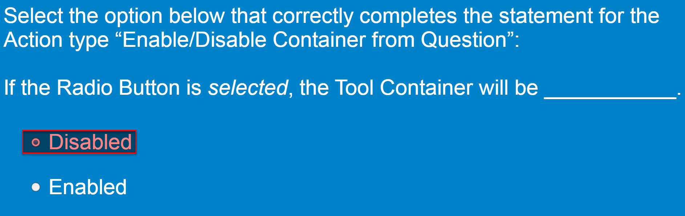

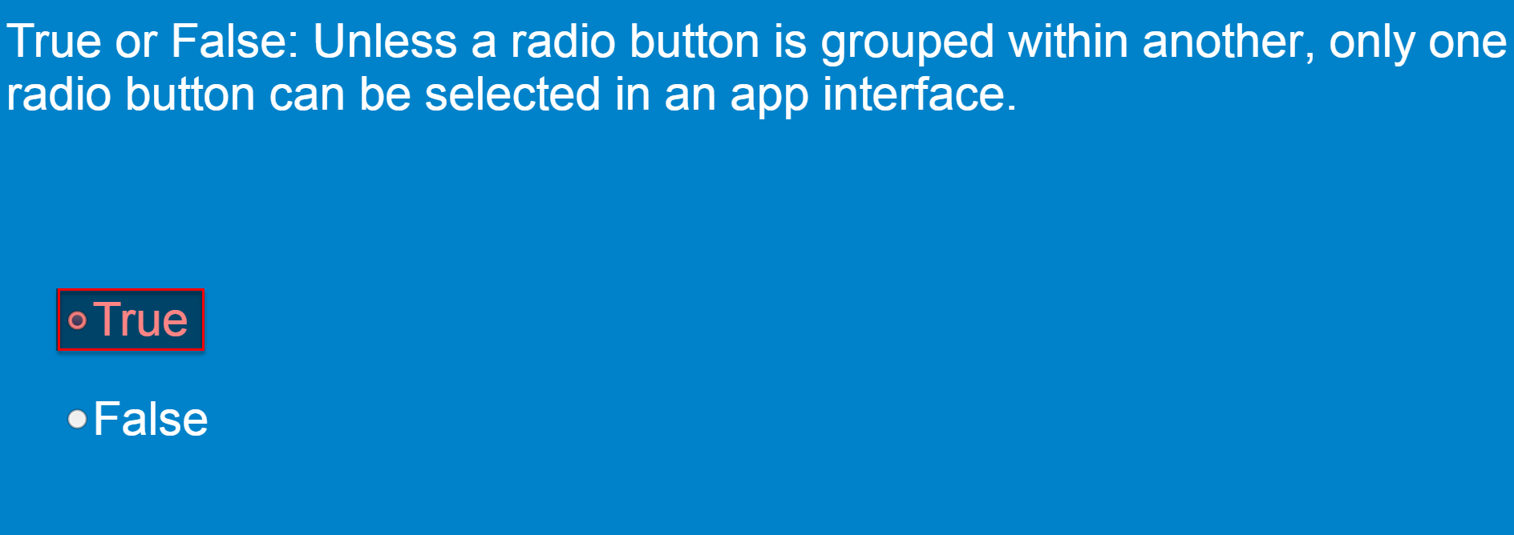

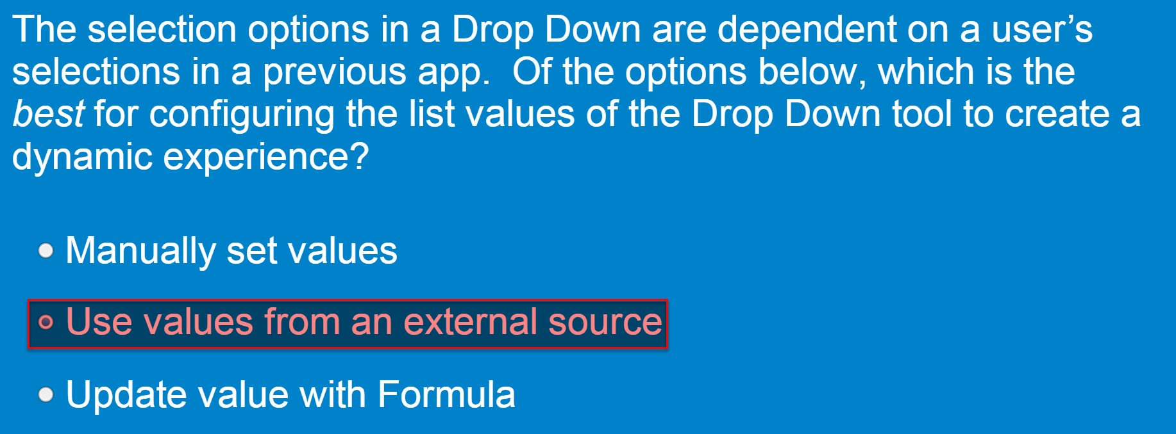

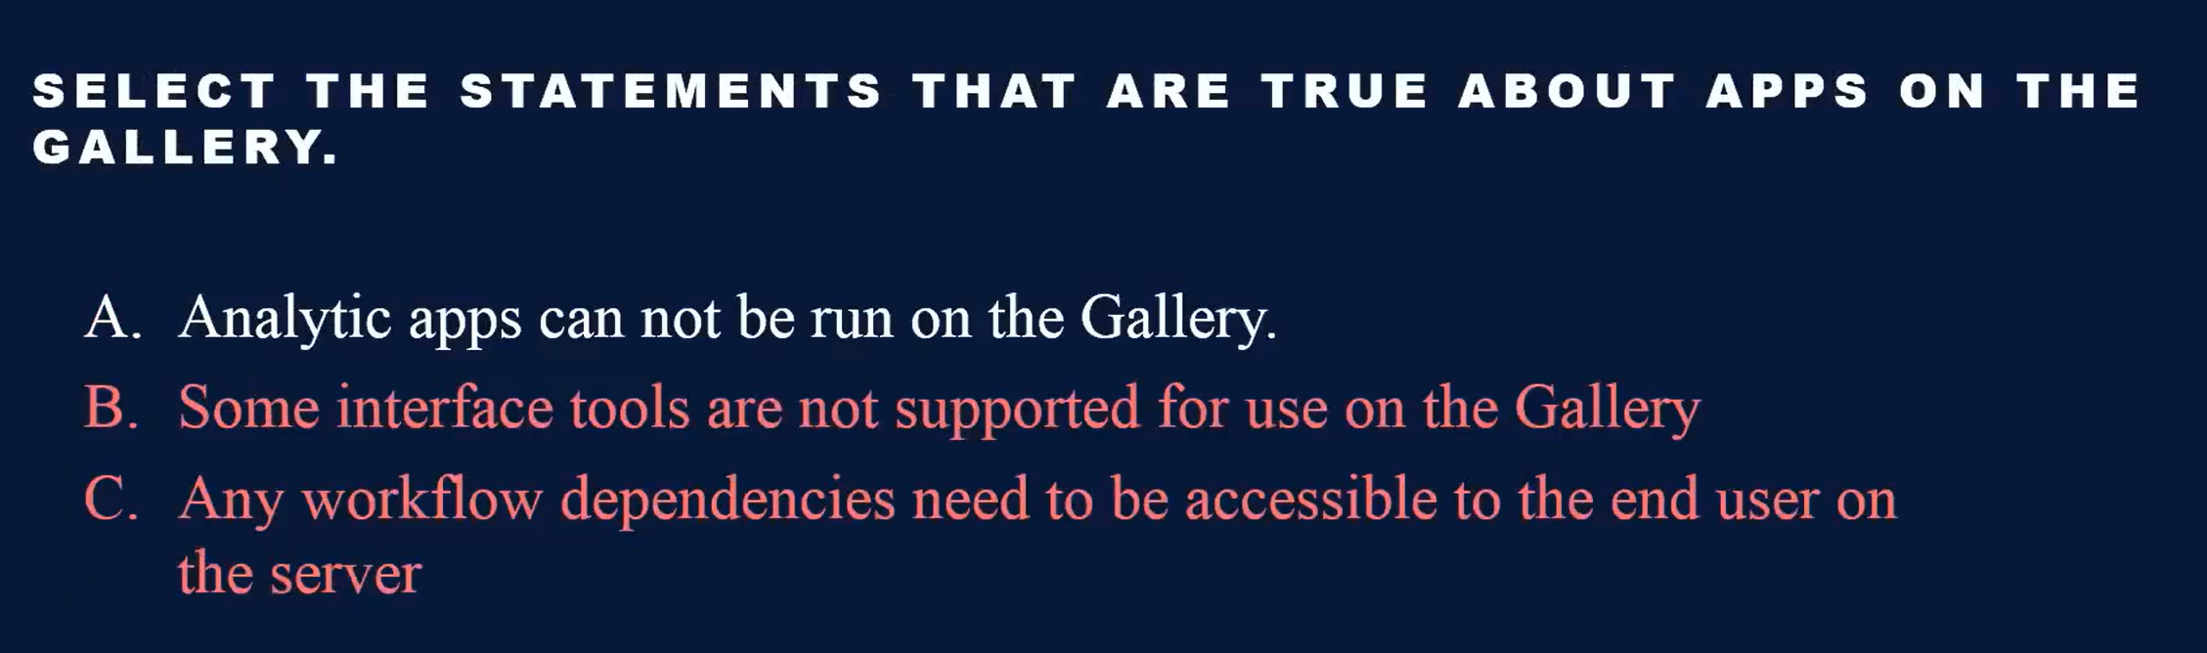

* [Macro]

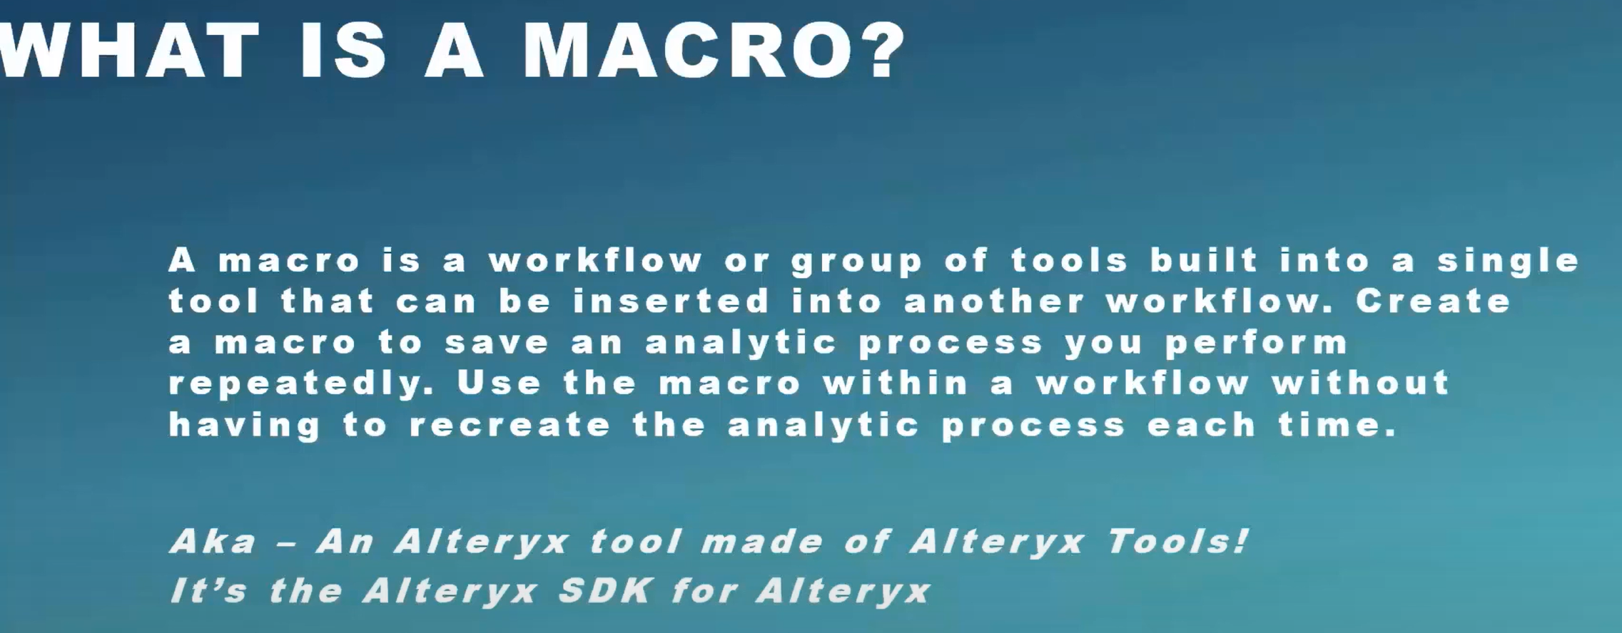

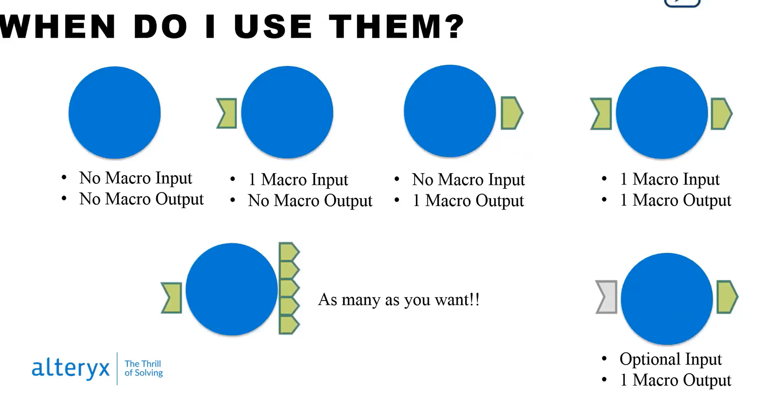

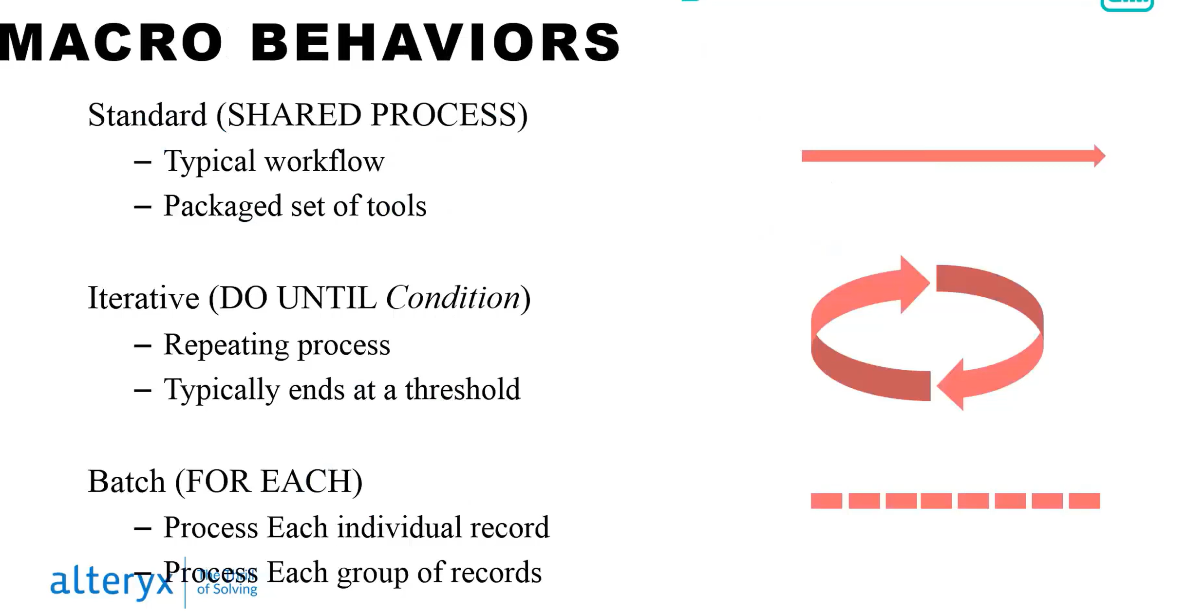

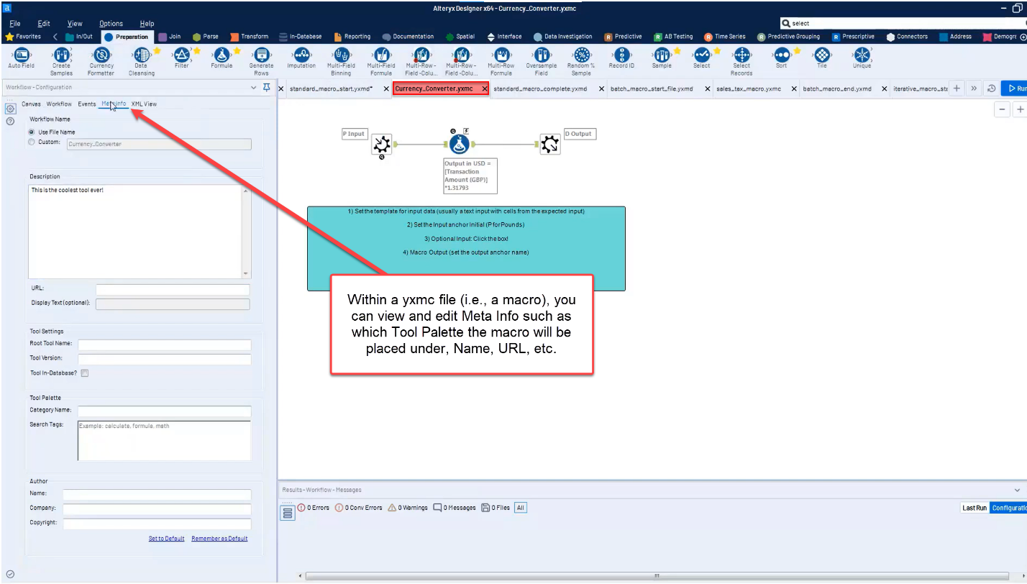

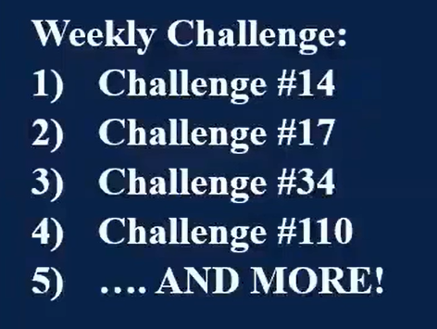

* [Analytic Apps]

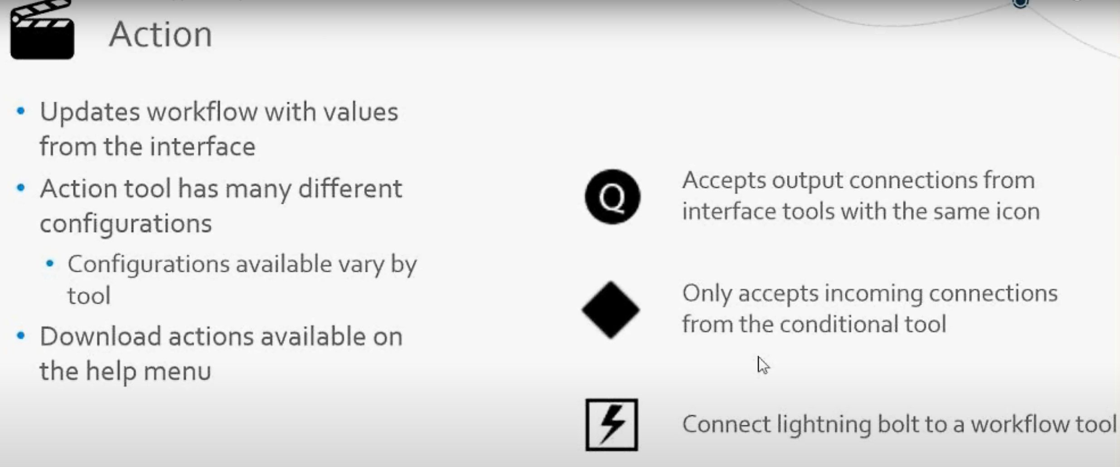

* Y
* Y
* Y
* Y
* Y
* Y
* Y
* Y
* Y
* Y
* Y
* Y
* Y
* Y
* Y
* Y
* Y
* Y
* Y

Practice Exam

<https://s3-us-west-1.amazonaws.com/ayx.policies/Advanced+Certification+Exam+Prep+Guide.pdf>

